**(PROJECT NAME XYZ.....)**

BY

(Student Name)

Registration No.

(Student Name)

Registration No.

Project submitted in partial fulfillment of the requirements for the degree of

Bachelors of Science

In

Software Engineerring



DEPARTMENT OF SOFTWARE ENGINEERING

GOVERNMENT COLLEGE UNIVERSITY, FAISALABAD.

August Year XYZ

**DECLARATION**

This work reported in this final project was carried out by us under the supervision of Mr. Nauman Ul Haq, Department of Software Engineering, GC University, Faisalabad, Pakistan.

I hereby declare that the title of project is (Project Name XYZ.....) and the contents of project are the product of my own research and no part has been copied from any published source (except the references, standard mathematical or genetic models /equations /formulas /protocols etc). I further declare that this work has not been submitted for award of any other degree /diploma. The University may take action if the information provided is found inaccurate at any stage.

**Signature of the Students/Scholars**

Name : (Student Name.....)

Registration No. : *******

Name : (Student Name.....)

Registration No. : ********

**DEDICATION**

I dedicate this study to my father for his unconditional love, support and patience. Without your constant encouragement and belief in me I would never have reached my dreams.It is also dedicated to my mother, who taught me that even the largest task can be accomplished if it is done one step at a time. Thank You!

**CERTIFICATE BY SUPERVISORY COMMITTEE**

We certify that the contents and form of thesis submitted by Farva, Registration No ************ and (Student Name.....), Registration No ********** has been found satisfactory and in accordance with the prescribed format. We recommend it to be processed for the evaluation by the External Examiner for the award of degree.

Signature of Supervisor …........……………….

Name: .........................…………………….........

Designation with Stamp……………………….

**Co-Supervisor (if any)**

Signature ………………......………………….

Name: …………………......…………………..

Designation with Stamp……………………….

**Member of Supervisory Committee**

Signature …….......…………………………….

Name: ………......……………………………..

Designation with Stamp……………………….

**Member of Supervisory Committee**

Signature ………….....………………………...

Name: …………......…………………………..

Designation with Stamp……………………….

**Chairperson**

Signature with Stamp…………….....…………

**Dean / Academic Coordinator**

Signature with Stamp………….………………

**ACKNOWLEDGEMENTS**

I wish to express my sincere gratitude to the following people for their contribution to this study:

First and foremost, I would like to thank God Almighty for giving me the strength, knowledge, ability and opportunity to undertake this final year project and to persevere and complete it satisfactorily. Without his blessings, this achievement would not have been possible **Mr. Nauman Ul Haq**, my research supervisor, for his valuable guidance, commitment, and support. **Mr. Nauman Ul Haq** has been the ideal final year project supervisor. His sage advice, insightful criticisms, and patient encouragement aided the writing of this report in innumerable ways. I would also like to thank friend whose steadfast support of this project was greatly needed and deeply appreciated. My parents, who have always been a source of support and have encouraged me to achieve my goals throughout my years of study. My siblings, for their support, encouragement and patience. The teachers who participated in my study, for their time, opinions and assistance. Special thanks go to my team members, who help me to assemble the parts and gave suggestion about the task **“(PROJECT NAME XYZ.....)”.**

**Signature of the Students/Scholars**

***************

Registration No. : ************

************

Registration No. : *******

Table of Contents

1 Introduction of (PROJECT NAME XYZ.....) 2

1.1 Android Technology 2

1.2 Hardware Requirement Android 2

1.3 The Global Positioning System 3

1.4 Purpose of using GPS 3

1.5 Importance for Government College University Faisalabad 3

1.6 Functionality of (PROJECT NAME XYZ.....) 4

1.7 Modules 5

1.8 Benefits 5

1.9 Objective: 5

1.10 Features 5

1.10.1 Features of Diver’s app 5

1.11 Features of Client’s app 6

1.12 Functionality 7

1.13 Driver’s module: 7

1.13.1 Client’s module: 7

1.14 Purposes & Benefits of both Apps 7

1.15 Introduction to Maps 8

1.15.1 Map 8

1.15.2 Google features: 8

1.16 Bing Map introduction 8

1.16.1 Bing features: 9

1.17 Why we choose Google map 9

1.18 Introduction to operating environment: 9

1.18.1 Xml 9

1.18.2 Features and Advantages of XML 9

1.18.3 Java: 10

1.18.4 Php 11

1.18.5 Php Files Used in (PROJECT NAME XYZ.....) 12

1.18.6 SQL queries 12

1.19 Tool Used to Develop “App” 13

1.19.1 Android Studio 13

1.19.2 Latitude and Longitude 14

1.20 GPS chip in android phone 14

1.20.1 GPS devices may be able to indicate: 15

1.20.2 GPS Device for Traking Bus 15

1.21 GPS Chip 16

1.21.1 Feature of GPS devices. 16

1.21.2 Comparison of Both 17

1.21.3 Why we use Android phone instead of GPS Device 17

2 Software Requirements Specifications 19

2.1 Introduction of the Requirement 19

2.2 Software Requirement Specification (SRSs) 19

2.3 Goals of software require specification 19

2.4 Gathering requirements from client 20

2.4.1 Typical Requirements Gathering Process 20

2.5 Capture Better Requirements 21

2.6 Different Types of Software Requirements 22

2.6.1 Business Requirements (BR) 22

2.6.2 Market Requirements (MR) 22

2.6.3 Functional Requirements (FR) – Use Cases 22

2.6.4 Non-Functional Requirements (NFR) 22

2.6.5 UI Requirements (UIR) 22

2.7 Requirements for (PROJECT NAME XYZ.....) 23

2.7.1 Functional Requirements 23

2.7.2 Registration Form 23

2.7.3 Map 23

2.7.4 Track location 24

2.7.5 Location permission 24

2.7.6 Internet connection permission 24

2.7.7 Non Functional Requirement of (PROJECT NAME XYZ.....) (Client) Application. 24

2.7.8 User friendly Interface 25

2.7.9 Easy to understand Interface for any non-technical user 25

2.7.10 Reliability 25

2.7.11 Security 26

2.7.12 Usability 26

2.7.13 Map 27

2.7.14 Track location 27

2.7.15 Location permission 27

2.7.16 Internet connections permission 28

2.8 Non Functional Requirement of (PROJECT NAME XYZ.....) (Client) Application 28

2.8.1 User friendly Interface 28

2.8.2 Easy to understand Interface for any non-technical user 29

2.8.3 Reliability 29

2.8.4 Security 29

2.8.5 Usability 30

3 Software Design Description 32

3.1 METHODOLOGY: 32

3.2 Unified Modeling Language: 32

3.3 Designing Technique: 33

3.4 Waterfall Model: 33

3.4.1 Why we used waterfall model: 33

3.4.2 Digram of Waterfall Model 34

3.4.3 Definition: 34

3.5 System Features: 35

3.5.1 System Features 1: 35

3.5.2 System Features 2: 36

3.6 Use case Diagram: 36

3.6.1 Use case 1: 36

3.6.2 Use case 2: 37

3.6.3 Use case 3: 38

3.7 Entity Relation Diagram 39

3.7.1 The elements of an ERD are: 39

3.7.2 Steps involved in creating an ERD include: 40

3.8 System Sequence diagram 40

3.9 System Sequence: 40

3.9.1 Overview 40

3.9.2 Advantages of sequence diagram 40

3.9.3 Driver Base Sequence diagram 41

3.9.4 Client Base Sequence diagram 42

3.10 Context Level 1 43

3.10.1 Usage 43

4 Software Coding & Implementation 45

4.1 User Guidelines for (Project Name XYZ.....) 45

4.1.1 Clicking on Launcher Icon 45

4.1.2 Clicking on Show Button 48

4.1.3 Clicking on Refresh Button 49

4.1.4 Clicking on Arrow button 49

4.1.5 Clicking on Maps Button 51

4.1.6 Clicking on About 53

4.1.7 Clicking on Contact Us 55

4.1.8 Getting Started with (Project Name XYZ.....) Driver’s App 56

4.1.9 Starting tracking 57

4.2 Code of Main activity 60

4.2.1 Explaination 60

4.2.2 MainActivity.xml 60

4.2.3 MainActivity.java 61

4.3 Maps Activity 62

4.3.1 Explaination 63

4.3.2 Activiy_Maps.xml 63

4.3.3 MapsActivity.java 65

4.4 GET.PHP 70

4.4.1 Explaination 71

5 Software Test Documentation 73

5.1 Project Testing 73

5.2 Purposes of testing 73

5.3 Benefits of Automated Software Testing 74

5.3.1 Efficient Testing 74

5.3.2 Up gradation and Reusability 74

5.3.3 Consistency 74

5.3.4 Unique Programmability and Shelf Life 75

5.3.5 User Environment Simulation 75

5.4 The basic levels of testing are: 75

5.5 User need acceptance Testing 76

5.5.1 Who perform user acceptance testing 76

5.6 Prerequisites of User Acceptance Testing 76

5.7 System Testing 77

5.8 Analogy 77

5.8.1 Method 77

5.8.2 Tasks 77

5.8.3 When is it performed? 77

5.8.4 Who performs it? 77

5.9 Unit Testing: 78

5.9.1 Who performs it? 78

5.10 Integration Testing 79

5.11 System Testing 79

5.12 Acceptance Testing 79

5.13 Validation Check 79

5.14 Implementation 79

5.15 System Verification 80

5.16 Alpha Testing 81

5.17 Beta Testing 81

5.18 Types of Beta Testing 81

6 Post Mortem Report 84

6.1 Our roles & tasks 84

6.2 What worked well? 84

6.3 Team effectiveness 84

6.4 Lesson learned 84

6.5 Conclusion of the Project: 85

**List OF FIGURES**

Fig 1.1:Government College University Faisalabad 4

Fig 1.2:Map 6

Fig 1.3:GPS Chip 16

Fig 1.4:GPS Device 17

Fig 3.1:Waterfall Model 34

Fig 3.2:Use Case of Developer 36

Fig 3.3:Use Case of Driver 37

Fig 3.4:Use Case of Client 38

Fig 3.5:Entity Relationship Diagram 39

Fig 3.6:System Sequence Diagram for Driver's App 41

Fig 3.7:System Secquence Diagram of client app 42

Fig 3.8:Context Level Diagram 43

Fig 4.1:Launcher Icon 45

Fig 4.3:Splash Screen 46

Fig 4.2:Main Activity of Client App 47

Fig 4.4:Maps Activity of Client App 48

Fig 4.5:Arrow Button on Client App 49

Fig 4.6:Clicked on Arrow Button 50

Fig 4.7:Clicking on Maps Button 51

Fig 4.8:More Options in Maps 52

Fig 4.9:About Activity: 53

Fig 4.11:Contact Activity 55

Fig 4.12:Registration Activity 56

Fig 4.13:Main Screen of (Project Name XYZ.....) Driver's App 57

Fig 4.14:Getting Location in (Project Name XYZ.....) Driver's App 58

Fig 4.15:Maps Activity of (Project Name XYZ.....) 59

**Chapter 1**

**Introduction of (PROJECT NAME XYZ.....)**

# Introduction of (PROJECT NAME XYZ.....)

## Android Technology

Android is a name that was introduced by American search engine **company (**Google Inc.). Todays it is a popular technology in cell phones, as it is an operating system which is capable of running multiple application programs. After iPhones it is a complete revolution in the mobile technology.

Android has there are a large community of developers they writing application programs which is called “apps” that increase the functionality of the devices.150, 000 apps available for Android. Android Market is the online app store run by Google. “Canalys” reported that in Q4 2010 the Android operating system was the world’s best-selling smart phone platform. Jumping from 23.5 percent, Android now represents 31.2 percent of the U.S smart phone market.

Android is an open-source software which consists of Java applications. These Java application are running on a Java-based, object-oriented application framework running on a Dalvik virtual machine featuring JIT compilation on top of Java core libraries. Libraries written in C incorporate the surface manager, OpenCore media framework, SQLite relational database management system, OpenGL ES 2.0 3D graphics API, WebKit layout engine, SGL graphics engine, SSL, and Bionic libc. The Android operating system consists of 12 million lines of code including 3 million lines of XML, 2.8 million lines of C, 2.1 million lines of Java, and 1.75 million lines of C++. (Christopher T.)

## ****Hardware Requirement Android****

The Android Operating System can be used as an operating system for cell phones, notebooks and tablets, including the Dell Streak, Samsung Galaxy Tab, TV and other devices. The first commercially available phone to run the Android operating system was the HTC Dream, released on 22 October 2008. In early 2010 Google collaborated with HTC to launch its flagship Android device, the Nexus One. This was followed later in 2010 with the Samsung-made Nexus S. The Android technology is on evolution and its evolving day by day to provide its consumers with the best technology.

## The Global Positioning System

**The Global Positioning System** is a global navigation satellite system (GNSS) developed by the United States Department of Defense and managed by the United States Air Force 50th Space Wing.It is the only fully functional GNSS in the world. It can be used freely, and is often used by civilians for navigation purposes. After it became fully operational in 1993, GPS has been used as an aid to navigation worldwide. It is also a useful tool for map-making, land surveying, commerce, scientific uses, and hobbies such as geo-caching. Also, the precise time reference is used in many applications. For instance, the scientific study of earthquakes. GPS is also an essential synchronization resource of cellular networks, like the Qualcomm CDMA air interface used by many wireless carriers in several countries. You can also view the latitude and longitude coordinates of your current location.

## Purpose of using GPS

GPS is used for navigation and provides continuous and timing information position of things anywhere in the world under any weather condition. The Global Positioning System (GPS) is a constellation of satellites that orbit the earth twice a day, transmitting exact time and position (latitude, longitude and altitude) information and photos. Users can determine their location anywhere on the Earth by using GPS Technology. The complete system consists of 24 satellites orbiting about 12,000 miles above the Earth, and five ground stations to monitor and manage the satellite constellation. These satellites provide 24-hour-a-day coverage for both two-and three-dimensional positioning anywhere on Earth.

## Importance for Government College University Faisalabad

We are making a (PROJECT NAME XYZ.....) ANDROID APP to let students know where some shuttle is right now. By downloading this app and getting online, students will locate bus whether it is in new campus or on its way to new campus or in new campus and vice versa. Thus this app will track busses between new and old campuses of GCUF. This will be a great relaxation for students who wait daily for shuttle and wonder if any is coming to take them on or not.The university is divided in two campuses Old campus and new campus some student are hostelries in Old campus hostel and there classes are held in new campus and some are hostelries in new campus and there classes are in old campus. Some student live near to government college university Faisalabad old campus and they studies in new campus so in this situation they face a lot of difficulties on traveling on university buses their major issue is time management they have no idea of exact time when the bus is coming. (PROJECT NAME XYZ.....) is an android app which is overcome the problems of student of gourmet college university Faisalabad. This application will provide the current location of buses which will stand on old campus bus stop or on its way or may be stand on new campus b us stop. We have two app

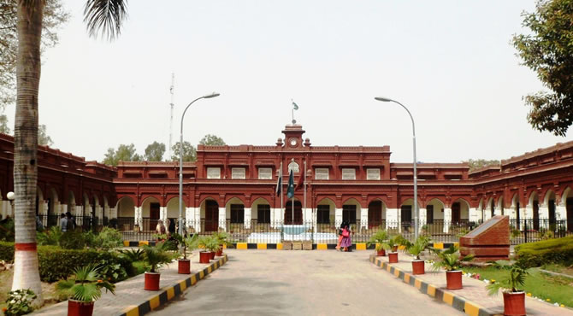

Fig 1.1:Government College University Faisalabad

* **s1st Driver’s App**

This app specifically developed for drivers only drivers can install this app on their phones

* **2nd Client App**

This app specifically developed for drivers all university students can easily installed on their phone, through mobile’s “Play Store”.

## Functionality of (PROJECT NAME XYZ.....)

1. Search driver’s (busses) current location
2. Send driver’s (busses) location to the server
3. Student can track busses location
4. Calculate total distance between busses and campus
5. Calculate total time duration

## Modules

* GPS module
* Internet connection
* Android phone

## Benefits

It is an open source application everyone can download and use it without any cost and any payment. By using this application user need internet connection (wifi or mobile data) for searching desired bus location.

When driver of bus turned on his GPS location by using his android cell phone then this application tells about his current location and this application send his current location to the server on the other hand student by using search button they can search their desired bus locations which he wants to find. It is an informative application for Student. so, this application provides a complete guideline about location of a shalte. Throug this app student will feel relex and they also save their time which they are waisting for waiting a bus on bus stand.

## Objective:

This application fulfill the problem of student who are standingn on Shaltle stop and waiting for bus they have no idea when the bus is come and mostly they have to wait for many time. In summer thera are much hoter day and sometime student are standing 30 to 40 minutes for waiting a bus in this way they waist both their engery and time.So if they download and install it they will feel easy to know time bus comming time and its current location and also know how many buses on the way.

## Features

### Features of Diver’s app

**Start Button**

* + App start from this button
  + After press this button directly move to registration Form

**Registration From**

Registration from appears only Once when driver installed this App its asked driver’s name and Store it in database.

**Mapping**

This Map search driver’s (buses) Current location and send this location to the server where the students can see where the bus on the road between Old campus and new.

## Features of Client’s app

**The client app**

Client App is basically “student’s App” when the students Install it in their android mobiles, There is no need to Registration themselves. After install this app students will find the location of all University buses.

**Mapping**

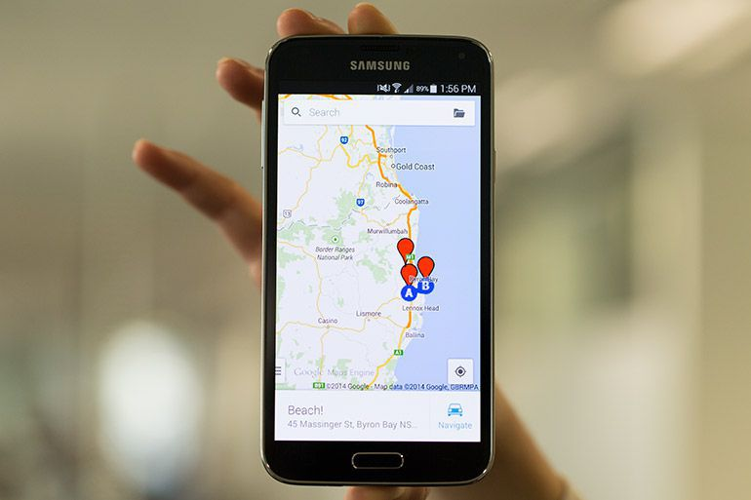Map is paper on screen which show the location of buses and direction on road.

Fig 1.2:Map

## Functionality

## **Driver’s module**:

* + - * Fetch driver’s (busses) current location (Latitude and Longitude).
      * Convert location to area name (geo coding).
      * Send driver’s (busses) location, area name and time of fetching location to the server.
      * Run the app as background process too.
      * Communicate Between both apps (Driver & client).
      * Location request If off at the begging of running the app.

### Client’s module:

* + - * Display Map
      * Download data from server.
      * Show the details as text.
      * Show all locations on map by markers
      * User can also see the detail of a specific bus by clicking on it on the map.
      * See how many buses on its way.

## Purposes & Benefits of both Apps

* + - * Locate Busses: By downloading this app, students will locate bus whether it is in new campus or on its way to new campus and vice versa. This will be a great relaxation for students who wait daily for busses and wonder if any is coming to take them on or not
      * Bus administrators will handle busses more efficiently.
      * With few necessary changes this app can be proved as a powerful administrative tool for others too like for some rent a car or for some pizza home delivery.
      * Cheaper than other tracking methods.
      * Easy to implement and cheaper to deploy
      * Provide Google Map facilities
      * Free of cost
      * Save the student Time and energy.
      * Save the student from a large number of weather difficulties.
      * There is no similar app in the history of GC University.
      * Simplest interface everyone can be operate it.
      * This app is not demand any extra Accesses except location request.
      * Client app also useful for all faculty member they also track the bus location.
      * Live streaming.

## Introduction to Maps

### Map

Google Maps is a web mapping service developed by Google. It offers satellite imagery, street maps, 360° panoramic views of streets (Street View), real-time traffic conditions (Google Traffic), and route planning for traveling by foot, car, bicycle (in beta), or public transportation.

Google maps makes heavy use of JavaScript, this leads to the transitions feeling a lot less smooth and more choppy when zooming. Google Maps gives you 3 buttons on the top right of the map to switch between “Map*–*Satellite*–*Terrain*”* views. Unlike Bing maps, the left hand side doesn’t serve any purpose when you are scrolling around the map.

### Google features:

* + - * Links to places
      * User created maps
      * Random Photos

## Bing Map introduction

BingMaps (previously Live Search Maps, Windows Live Maps, Windows Live Local, and MSN Virtual Earth) is a [web mapping](https://en.wikipedia.org/wiki/Web_mapping) service provided as a part of [Microsoft](https://en.wikipedia.org/wiki/Microsoft)'s [Bing](https://en.wikipedia.org/wiki/Bing_(search_engine)) suite of search engines and powered by the [Bing Maps for Enterprise](https://en.wikipedia.org/wiki/Bing_Maps_for_Enterprise) framework.

Bing uses the power of Silverlight to give you a much smoother loading experience and gives way to more interactive features such as Flickr, Photosynth and the upcoming Worldwide Telescope, inside the platform. Bing maps automatically changes the style of map as you zoom in and out to give you the best map style. You have the option to change this to manual so you can control which view you see at all times.

### Bing features:

* + - * Current weather
      * Featured Photosynth’s
      * Popular categories of search for that area

## Why we choose Google map

* + - * Android is a services which provided by Google and Google account is required for android “Play Store” because is all Google service so Google is prefer Google map
      * Google map has more feature as compare to Bing map. Google is Most frequently use and most popular Map then other maps
      * Google map is reliable there are a large number of location are submitted in Google map in other hand Bing map has also a lot of location but many number of location are missing so it is not as reliable as Google map.
      * These are the reasons to select Google map rather than other maps.

## Introduction to operating environment:

### **Xml**

Xml means Extensible Markup Language. Android provides a straightforward XML vocabulary that corresponds to the View classes and subclasses. The goal of using Android's XML vocabulary, is to quickly design UI layouts and the screen elements they contain, in the same way that creating web pages in HTML, with a series of nested elements. XML (eXtensible Markup Language), like HTML, is a markup language for marking up the structure of a text document. It is a subset of Standard General Markup Language (SGML). XML is not a programming language like Java or C#. It is developed and maintained by World-Wide Web Consortium (W3C).

Some feature and advantages of XML are below.

### Features and Advantages of XML

* + - * XML separates data from HTML
      * XML simplifies data sharing
      * XML simplifies data transport
      * XML simplifies Platform change
      * XML can be used to create new internet languages

### **Java**:

The aim is to translate JAVA in machine language understood by Android. A Java framework that allows applications running on the virtual machine to organize and cooperate. Java provide a way to handle backend performed actions. Android applications are developed using the Java language. As of now, that’s your only option for native applications. Java is a very popular programming language developed by Sun Microsystems (now owned by Oracle). Developed long after C and C++, Java incorporates many of the powerful features of those powerful languages while addressing some of their drawbacks. Still, programming languages are only as powerful as their libraries. These libraries exist to help developers build applications.

**Important core features of java:**

* + - * It is easy to learn and understand
      * It is designed to be platform-independent and secure, using virtual machines.
      * It is object-oriented

Android relies heavily on these Java fundamentals. The Android SDK includes many standard Java libraries (data structure libraries, math libraries, graphics libraries, networking libraries and everything else you could want) as well as special Android libraries that will help you develop awesome Android applications.

**Other 8 Features of Java**

* + - * [forEach() method in Iterable interface](http://www.journaldev.com/2389/java-8-features-with-examples#iterable-forEach)
      * [default and static methods in Interfaces](http://www.journaldev.com/2389/java-8-features-with-examples#interface-default-static-method)
      * [Functional Interfaces and Lambda Expressions](http://www.journaldev.com/2389/java-8-features-with-examples#functional-interface-lambdas)
      * [Java Stream API for Bulk Data Operations on Collections](http://www.journaldev.com/2389/java-8-features-with-examples#java-stream-api)
      * [Java Time API](http://www.journaldev.com/2389/java-8-features-with-examples#java8-time)
      * [Collection API improvements](http://www.journaldev.com/2389/java-8-features-with-examples#java8-collection)
      * [Concurrency API improvements](http://www.journaldev.com/2389/java-8-features-with-examples#java8-concurrency)
      * [Java IO improvements](http://www.journaldev.com/2389/java-8-features-with-examples#java8-io)0
      * [Miscellaneous Core API improvements](http://www.journaldev.com/2389/java-8-features-with-examples#java8-core)

### Php

PHP is a [script](http://searchenterpriselinux.techtarget.com/definition/script) language and interpreter that is freely available and used primarily on [Linux](http://searchenterpriselinux.techtarget.com/definition/Linux) Web servers. PHP, originally derived from Personal Home Page Tools, now stands for PHP: Hypertext Preprocessor, which the PHP FAQ describes as a "recursive acronym”. PHP executes on the server, while a comparable alternative, [JavaScript](http://searchmicroservices.techtarget.com/definition/JavaScript), executes on the client. PHP is an alternative to Microsoft's [Active Server Page](http://searchwindowsserver.techtarget.com/definition/Active-Server-Page) (ASP) technology. As with ASP, the PHP script is embedded within a Web page along with its [HTML](http://searchsoa.techtarget.com/definition/HTML). Before the page is sent to a user that has requested it, the Web server calls PHP to interpret and perform the operations called for in the PHP script. An HTML page that includes a PHP script is typically given a file name suffix of ".php" ".php7," or ".phtml". Like ASP, PHP can be thought of as "dynamic HTML pages," since content will vary based on the results of interpreting the script. PHP is free and offered under a source license. The main features of php is; it is open source scripting language so you can free download this and use. PHP is a server site scripting language. It is open source scripting language. It is widely used all over the world.

**Feature of PHP**

* **Simple**

It is very simple and easy to use, compare to other scripting language it is very simple and easy, this is widely used all over the world.

* **Interpreted**

It is an interpreted language, i.e. there is no need for compilation.

* **Faster**

It is faster than other scripting language e.g. asp and jsp.

* **Open Source**

Open source means you no need to pay for use php, you can free download and use.

* **Platform Independent**

PHP code will be run on every platform, Linux, UNIX, Mac OS X, and Windows.

* **Case Sensitive**

PHP is case sensitive scripting language at time of variable declaration. In PHP, all keywords (e.g. if, else, while, echo, etc.), classes, functions, and user-defined functions are NOT case-sensitive.

**Php used in (PROJECT NAME XYZ.....)**

We used Php languge for creating database in our project php use to create a website in which we save drivers information and current loction these information store at server side and used to send the client when he send requise to see location. Php langue use to manage SQL command of (PROJECT NAME XYZ.....) We have five php file these name are mention below and these detail are explain in coding chapter.

### Php Files Used in (PROJECT NAME XYZ.....)

1. Config.php
2. Get.php
3. Newrec.php
4. Register.php
5. Senddata.php

### SQL queries

This lesson teaches the reader the fundamentals of the SQL SELECT statement, which is used to query the database for useful information. The database user has many options with the SELECT statement, proving that the query is the most robust feature of SQL.SQL (Structured Query Language) is a database computer language designed for managing data in relational database management systems (RDBMS). SQL,is a standardized computer language that was originally developed by IBM for querying, altering and defining relational databases,using declarative statements.

SQL Queries Feature

Making Cockroach DB easy to use is a top priority for us, so we chose to implement SQL. However, even though SQL has a standard, no database implements all of it, nor do any of them have standard implementations of all features. To understand which standard SQL features we support (as well as common extensions to the standard), use the table below.

* Component lists the components that are commonly considered part of SQL.
* Supported shows Cockroach DB's level of support for the component.
* Details provides greater context about the component.

## Tool Used to Develop “App”

### Android Studio

**Android Studio** is the official [integrated development environment](https://en.wikipedia.org/wiki/Integrated_development_environment) (IDE) for the [Android](https://en.wikipedia.org/wiki/Android_(operating_system)) platform. It was announced on May 16, 2013 at the [Google I/O](https://en.wikipedia.org/wiki/Google_I/O) conference. Android Studio was in early access preview stage starting from version 0.1 in May 2013, then entered beta stage starting from version 0.8 which was released in June 2014. The first stable build was released in December 2014, starting from version 1.0.

Based on [JetBrains](https://en.wikipedia.org/wiki/JetBrains)' [IntelliJ IDEA](https://en.wikipedia.org/wiki/IntelliJ_IDEA) software, Android Studio is designed specifically for Android development. It is available for download on [Windows](https://en.wikipedia.org/wiki/Windows), [macOS](https://en.wikipedia.org/wiki/MacOS) and [Linux](https://en.wikipedia.org/wiki/Linux), and replaced [Eclipse Android Development Tools](https://en.wikipedia.org/wiki/Eclipse_(software)#Eclipse_ADT_.28Android_Development_Tools.29) (ADT) as Google's primary IDE for native Android application development.

Feature of android studio

* New features are expected to be rolled out with each release of Android Studio. The following features are provided in the current stable version.
* [Gradle](https://en.wikipedia.org/wiki/Gradle)-based build support
* Android-specific [refactoring](https://en.wikipedia.org/wiki/Code_refactoring) and quick fixes
* [Lint](https://en.wikipedia.org/wiki/Lint_(software)) tools to catch performance, usability, version compatibility and other problems
* [ProGuard](https://en.wikipedia.org/wiki/ProGuard_(software)) integration and app-signing capabilities
* Template-based wizards to create common Android designs and components
* A rich [layout editor](https://en.wikipedia.org/wiki/Graphical_user_interface_builder) that allows users to drag-and-drop UI components, option to [preview layouts](https://en.wikipedia.org/wiki/WYSIWYG) on multiple screen configurations
* Support for building [Android Wear](https://en.wikipedia.org/wiki/Android_Wear) apps
* Built-in support for Google Cloud Platform, enabling integration with Firebase Cloud Messaging (Earlier 'Google Cloud Messaging') and Google App Engine
* Android Virtual Device (Emulator) to run and debug apps

### Latitude and Longitude

**Latitude and longitude** are the units that represent the coordinates at geographic coordinate system. Just like every actual house has its address (which includes the number, the name of the street, city, etc), every single point on the surface of earth can be specified by the latitude and longitude coordinates. Therefore, by using latitude and longitude we can specify virtually any point on earth.

**Latitude**

The **latitude** has the symbol of phi, and it shows the angle between the straight line in the certain point and the equatorial plane. The latitude is specified by degrees, starting from 0° and ending up with 90° to both sides of the equator, making latitude Northern and Southern. The equator is the line with 0° latitude.

**Longitude**

The **longitude** has the symbol of lambda and is another angular coordinate defining the position of a point on a surface of earth. The longitude is defined as an angle pointing west or east from the Greenwich Meridian, which is taken as the Prime Meridian. The longitude can be defined maximum as 180° east from the Prime Meridian and 180° west from the Prime Meridian.

Both **latitude and longitude** are measured in **degrees**, which are in turn divided into minutes and seconds. For example, the tropical zone which is located to the south and to the north from the Equator is determined by the limits of 23°26'13.7'' S and 23°26'13.7'' N. Or. For example, the geographical coordinates of the mount Ngauruhoe in New Zealand, famous with its being the filming area for the Lord of the Rings movie, has the geographic coordinates of 39°09'24.6''S 175°37'55.8''E.

## GPS chip in android phone

GPS is a small chip. Android phones have a GPS chip in them.  is a device that is capable of receiving information from [GPS satellites](https://en.wikipedia.org/wiki/GPS_satellites) and then to accurately calculate the device's geographical location. The [Global Positioning System](https://en.wikipedia.org/wiki/Global_Positioning_System) (GPS) uses a [global navigation satellite system](https://en.wikipedia.org/wiki/Satellite_navigation) (GNSS) made up of a network of a minimum of 24, but currently [30, satellites](https://en.wikipedia.org/wiki/List_of_GPS_satellites) placed into orbit by the [U.S. Department of Defense](https://en.wikipedia.org/wiki/United_States_Department_of_Defense).

But inAndroid phone GPS not work without an internet connection and GPS required permission on Location on and internet connection on otherwise it does not work.

### **GPS devices may be able to indicate:**

* Roads or paths that might be taken to get to the destination,
* If some roads are busy (now or historically) the best route to take,
* The location of food, banks, hotels, fuel, airports or other places of interests,
* The shortest route between the two locations,
* The different options to drive on highway or back roads.
* GPS devices can locate your dog from most any locale.
* GPS devices can direct you in real time as you locate your dog.

### GPS Device for Traking Bus

A [GPS navigation device](https://en.wikipedia.org/wiki/GPS_navigation_device) or GPS receiver, and when used for [vehicle navigation](https://en.wikipedia.org/wiki/Automotive_navigation_system) commonly referred to simply as a GPS, is a device that is capable of receiving information from [GPS satellites](https://en.wikipedia.org/wiki/GPS_satellites)  and then to accurately calculate the device's geographical location. The [Global Positioning System](https://en.wikipedia.org/wiki/Global_Positioning_System) (GPS) uses a [global navigation satellite system](https://en.wikipedia.org/wiki/Satellite_navigation) (GNSS) made up of a network of a minimum of 24, but currently [30, satellites](https://en.wikipedia.org/wiki/List_of_GPS_satellites) placed into orbit by the [U.S. Department of Defense](https://en.wikipedia.org/wiki/United_States_Department_of_Defense).

## GPS Chip

### Feature of GPS devices.

* 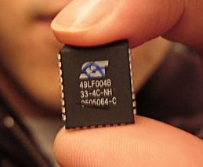The roads or paths available,

Fig 1.3:GPS Chip

* Traffic congestion and alternative routes,
* Roads or paths that might be taken to get to the destination,
* If some roads are busy (now or historically) the best route to take,
* The location of food, banks, hotels, fuel, airports or other places of interests,
* The shortest route between the two locations,
* Most people seeking GPS systems are looking for a device to help them obtain

directions to the places they are going.

* + These systems provide turn by turn navigation from origin to destination, making it almost impossible to get lost.
  + Those who want a GPS to help them find their way around Australia may wish to consider the following eight features when selecting a GPS system

The different options to drive on highway or back roads.

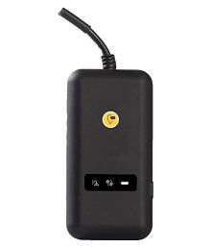**GPS Device**

Fig 1.4:GPS Device

### Comparison of Both

This page on GPS vs. A-GPS describes **difference between GPS and GPS-A**. Both the technologies help determine location on the earth. GPS is mainly employed in cars, planes and ships, while AGPS is employed in mobile phones. Though both have same application, let us see how both the features differ below. GPS stands for Global Positioning System and AGPS stands for Assisted Global Positioning System.GPS devices determine location information by directly communicating with satellites moving

### Why we use Android phone instead of GPS Device

* AsI explain above the working of both devices is same and functionality is also same both devices find the location with same technique.
* Now a day android phone is demand of society and almost everyone have an android phone so its feel reasonable for us to use and android phone and buses driver have android phone.
* It is cheapest way to implement our system because the price of GPS device is started from Rs. 9,999 to Rs. 55,799 and so on.
* We are student and these devices are much costly for us so we choose an economical way to deploy it.

**Chapter 2**

**Software Requirements Specifications**

# Software Requirements Specifications

## **Introduction of the Requirement**

In this chapter i breifly explan what is software require specification and how its collect from client and how many defficulities are faced during gathering requirement. This this chapter we are talking about (PROJECT NAME XYZ.....) requirements Functional and non functional.

## Software Requirement Specification (SRSs)

A software requirements specification (SRS) is a description of a [software system](https://en.wikipedia.org/wiki/Software_system) to be developed. It lays out functional and [non-functional requirements](https://en.wikipedia.org/wiki/Non-functional_requirements), and may include a set of [use cases](https://en.wikipedia.org/wiki/Use_case) that describe user interactions that the software must provide.

Software requirements specification establishes the basis for an agreement between customers and contractors or suppliers (in market-driven projects, these roles may be played by the marketing and development divisions) on what the software product is to do as well as what it is not expected to do. Software requirements specification permits a rigorous assessment of requirements before design can begin and reduces later redesign. It should also provide a realistic basis for estimating product costs, risks, and schedules. Used appropriately, software requirements specifications can help prevent software project failure.

The software requirements specification document enlists enough and necessary requirements that are required for the project development. To derive the requirements, the developer needs to have clear and thorough understanding of the products to be developed or being developed. This is achieved and refined with detailed and continuous communications with the project team and customer till the completion of the software.

## Goals of software require specification

The Software Requirements Specification (SRS) is a communication tool between stakeholders and software designers. The specific goals of the SRS are:

* Facilitating reviews
* Describing the scope of work
* Providing a reference to software designers (i.e. navigation aids, document structure)
* Providing a framework for testing primary and secondary use cases
* Including [features](https://en.wikipedia.org/wiki/Software_feature) to customer requirements
* Providing a platform for ongoing refinement (via incomplete specs or questions)

Reliability Availability Security Maintainability Portability.

## Gathering requirements from client

Following are the process which including to get require from client

### Typical Requirements Gathering Process

Our consultant is going to talk to a client about a new Intranet. The client already has an Intranet, but wants a new one. It works well in the main, but the technology is old and the client would like some new features. Over the course of several days our consultant quizzes the client about all areas of the system. He is a good consultant, so he does the following:

* Structures the meeting into particular topic areas (review of old system, interview with users, potential new features etc.) and works through them with the appropriate people.
* Takes notes from all his meetings.
* Spends some time himself working through the system, forming his own impressions.
* Writes up a report at the end of the requirements phase, with his recommendations. Our consultant reports back to his project team that he understands the problem, works with a developer to devise a solution, and sits back with a rosy feeling as the solution is built.
* Client thinks about a requirement
* Client communicates a requirement
* Consultant hears requirement
* Consultant documents requirement

## Capture Better Requirements

So how do we mitigate against these factors, if they are oh so inevitable in requirements gathering? Good question. Try the following tips. They won’t magically solve the problem, but they will all help you keep the percentage of the original requirement you record as high as possible:

**There are eight points to gather better requirement**

1. Firstly, accept you will never hit 100% accuracy. Bear it in mind at all times and it will drive you to capture better requirements.
2. Spend as long as you possibly can on this phase and talk to as many people as possible. Talk to people in a wide range of roles, but ask them all the same questions. You will be surprised how good an insight staff “on the shop floor” have about so called “management level” questions (and vice versa).
3. Ask “Why?” Ask it a lot. Never accept an answer in the requirements gathering phase without asking “why” at least five times. No matter the project, the technology, the company or the interviewee -- “Why?” is the best question.
4. Requirements gathering has to be conducted by as few people as possible. Imagine a different consultant carrying out each meeting in the scenario described above. Our percentage would plummet. If more than one person is really needed (and avoid it if you can), then the process has to be headed up and coordinated by a single person. Some single person must hold the whole problem in their head.
5. Always have a dedicated scribe. In meetings and workshops, the person conducting the session should never write the notes. If they are doing a good job (see the first point), then they just won’t have time.
6. Better still, use “dialogue mapping” techniques to document meetings. There is not enough room to go into this topic here, but this involves a dedicated scribe documenting decisions and questions using diagrams on a big screen that everyone can see.
7. Deliver outputs of requirements gathering to the client as often as possible. Always send them a copy of your raw meeting notes. Then follow up meetings with your findings. If you need to produce a formal report, go over your thinking and draft copies with the client as early as possible.
8. Your final report will not be perfect, so when development starts, keep talking to the client. If possible, keep showing them the solution as you build it to check your theories and ideas.

## Different Types of Software Requirements

The most common types of software requirements are:

### ****Business Requirements (BR)****

* These are high-level business goals of the organization building the product, or the customer who commissioned the project.
* These are usually provided as a single page of high-level bullets.

### ****Market Requirements (MR)****

* These drill down into BRs, but still are high-level. In addition to business goals, they also outline market needs.
* These are usually provided as a prioritized bulleted list or table, and are usually less than 5 pages long.

### ****Functional Requirements (FR) – Use Cases****

* These cover the functionality of the product in detail. [Use cases](http://www.accompa.com/product-management-blog/2009/09/19/use-cases-definition-requirements-management-basics/) are one of the [best ways of documenting functional requirements](http://www.accompa.com/product-management-blog/2009/09/22/use-cases-top-10-reasons-for-using-them-to-document-your-requirements/).
* Depending on the product being built, FRs can run several hundred pages.

### ****Non-Functional Requirements (NFR)****

* These are not related to the “functionality” of the product – but cover goals such as Reliability, Scalability, Security, Integration, etc.
* Many projects make the mistake of not specifying these explicitly.

### ****UI Requirements (UIR)****

* User interface specs are not considered “requirements” in traditional requirements management theory.
* Phooey! In my opinion, UI specs are indeed requirements ([what else are they?](http://www.accompa.com/product-management-blog/2009/11/20/should-user-interface-ui-be-a-part-of-requirements/)) – And in fact should be considered an integral part of requirements for any software that has a UI.

## **Requirements for (PROJECT NAME XYZ.....)**

I already explain about what software requirement specification is and how its gather so now I explain about (PROJECT NAME XYZ.....) requirements.

### Functional Requirements

In Software engineering and systems engineering, a functional requirement defines a function of a system or its component. Functional requirements may be calculations, technical details, data manipulation and processing and other specific functionality that define what a system is supposed to accomplish.

**Functional Requirement of (PROJECT NAME XYZ.....) (Driver) Application:**

* + - * Registration Form
      * Map
      * Track location
      * Location permission
      * Internet connection permission

### Registration Form

Our clients are GC Univeristy Faisalabad and student of GC Univeristy Faisalabad the univeristy provide the fecility to the student and employees to know about vehicle coming and going informatin throRegistration form on the start of the application use to store the Driver name in the database for future use and when any client used to know about driver name of comming bus this will also become benificial for this purpose.When all driver are register in system’s database so univeristy can easily check detail about drivers and who driver is missing and who are one duty.

### Map

Map activity display on mobile screen which show the current location of the driver and send this location to the server it is a great guid of driver because any new driver can easily understand his path.

### Track location

This application also used to find any your friend and family member and your destination path etc but it is possible on this condition if both person install this app (Runner and tracker). GPS devices in smartphone and other mobile devices are often used to track employees location of univeristy. Privacy advocates warn that the technology can also make it possible for advertisers, goverment, hackers and cyberstalkers to track users through their mobile devices.By using this app student can easily track driver current location and his name and his bus deatil this is a great relexment for student. Throught this app univeristy will also track buses and driver current location and save data in database. By downloading this app and getting online, students will locate bus whether it is in new campus or on its way to new campus or in new campus and vice versa. Thus this app will track busses between new and old campuses of GCUF.

### Location permission

Android apps will ask for a permission when they need it. For example, instead of giving an app access to your camera when you install it, you’ll be prompted the first time the app wants to access your camera.Android apps will ask for a permission when they need it. For example, instead of giving an app access to your camera when you install it, you’ll be prompted the first time the app wants to access your camera.

Mostly persons has turn off thiers mobile’s location and use google map in this way they can not find their location and also can not find others location beacuse latitude longitude does not work without turn on location.

### Internet connection permission

Mostly persons has turn off thiers internet and use google map in this way they can not find their location and also can not find others location beacuse latitude longitude does not work without turn on location and internet connection.Before you add networking functionality to your app, you need to ensure that data and location is turn on.

### Non Functional Requirement of (PROJECT NAME XYZ.....) (Client) Application.

In systems engineering and requirements engineering, a non-functional requirement (NFR) is a requirement that specifies criteria that can be used to judge the operation of a system, rather than specific behaviors. They are contrasted with functional requirements that define specific behavior or functions.

These are nonfunctional requirements in (PROJECT NAME XYZ.....) (Client)

* + - * User friendly Interface
      * Easy to understand Interface for any non-technical user
      * Reliability
      * Security
      * Usability

### User friendly Interface

Users must be able to select any option from the GUI and should get confirmation message back for every action. The interface should b easy and user friendly

When people download an app, they usually look for things such as design, functionality, and efficiency. These fine qualities are never more present than in the app’s interface. You can create an app that is artfully designed and visually stunning, but if no one can figure out to how to move beyond the home screen, it’s not going to sell well. No matter how flashy an app looks, what most people want is an app that does exactly.

### Easy to understand Interface for any non-technical user

Easy is something that can be done with ease, is not hurried, is not difficult, is free from anxiety or is comfortable. An example of easy is cooking a meal without the pressure of time. An example of easy is a hike that continues at the same elevation.

A user interface specification (UI specification) is a document that captures the details of the software user interface into a written document. The specification covers all possible actions that an end user may perform and all visual, auditory and other interaction elements.

### Reliability

Reliability is an attribute of any computer-related component (software, or hardware, or a network, for example) that consistently performs according to its specifications. It has long been considered one of three related attributes that must be considered when making, buying, or using a computer product or component. Reliability, availability, and serviceability - RAS, for short - are considered to be important aspects to design into any system. In theory, a reliable product is totally free of technical errors; in practice, however, vendors frequently express a product's reliability quotient as a percentage. Evolutionary products (those that have evolved through numerous versions over a significant period of time) are usually considered to become increasingly reliable, since it is assumed that [bug](http://searchsoftwarequality.techtarget.com/definition/bug) s have been eliminated in earlier releases. For example, IBM's [z/OS](http://searchdatacenter.techtarget.com/definition/z-OS) (an operating system for their [S/390](http://searchdatacenter.techtarget.com/definition/S-390) server series), has a reputation for reliability because it evolved from a long line of earlier [MVS](http://searchdatacenter.techtarget.com/definition/MVS) and [OS/390](http://searchdatacenter.techtarget.com/definition/OS-390) operating system versions.

### Security

Have you ever heard the old saying “You get what you get and you don’t get upset”? While that may apply to after school snacks and birthday presents, it shouldn’t be the case for software security. When a software feature is deployed, it isn’t simply accepted by the software owner; there’s a strategic process of critique, justification, and analysis before its deployed. Security should be treated with the same attention to detail. After all, secure software doesn’t just happen out of nowhere it has to be a requirement of the strategic development process. The requirements should be clear, consistent, testable, and measurable to effectively deploy secure software.

Traditionally, requirements are about defining what something can do or be. A hammer has to be capable of driving nails. A door lock needs to keep a door closed until it’s unlocked with a specific key. A car needs to move travelers from point A to point B along the nation’s roads. It also needs to work with the modern gasoline formulation. These types of requirements work fine for physical objects, but fall short when designing software.

### Usability

Usability is the measure of a product's potential to accomplish the goals of the user. In information technology, the term is often used in relation to software applications and Web sites, but it can be used in relation to any product that is employed to accomplish a task (for example, a toaster, a car dashboard, or an alarm clock). Some factors used in determining product usability are ease-of-use, visual consistency, and a clear, defined process for evolution.

**Functional Requirement of (PROJECT NAME XYZ.....) (Client) Application.**

* + - * Map
      * Track location
      * Location permission
      * Internet connection permission

### Map

Map activity display on mobile screen which show the current location of the driver and send this location to the server it is a great guid of driver because any new driver can easily understand his path.

### Track location

This application also used to find any your friend and family member and your destination path etc but it is possible on this condition if both person install this app (Runner and tracker).

GPS devices in smartphone and other mobile devices are often used to track employees location of univeristy. Privacy advocates warn that the technology can also make it possible for advertisers, goverment, hackers and cyberstalkers to track users through their mobile devices.By using this app student can easily track driver current location and his name and his bus deatil this is a great relexment for student. Throught this app univeristy will also track buses and driver current location and save data in database. By downloading this app and getting online, students will locate bus whether it is in new campus or on its way to new campus or in new campus and vice versa. Thus this app will track busses between new and old campuses of GCUF.

### Location permission

Android apps will ask for a permission when they need it. For example, instead of giving an app access to your camera when you install it, you’ll be prompted the first time the app wants to access your camera. Android apps will ask for a permission when they need it. For example, instead of giving an app access to your camera when you install it, you’ll be prompted the first time the app wants to access your camera.Mostly persons has turn off thiers mobile’s location and use google map in this way they can not find their location and also can not find others location beacuse latitude longitude does not work without turn on location.

### Internet connections permission

Mostly persons has turn off thiers internet and use google map in this way they can not find their location and also can not find others location beacuse latitude longitude does not work without turn on location and internet connection.Before you add networking functionality to your app, you need to ensure that data and location is turn on.

## Non Functional Requirement of (PROJECT NAME XYZ.....) (Client) Application

In systems engineering and requirements engineering, a non-functional requirement (NFR) is a requirement that specifies criteria that can be used to judge the operation of a system, rather than specific behaviors. They are contrasted with functional requirements that define specific behavior or functions.

These are nonfunctional requirements in (PROJECT NAME XYZ.....) (Client)

* + - * User friendly Interface
      * Easy to understand Interface for any non-technical user
      * Reliability
      * Security
      * Usability

### User friendly Interface

Users must be able to select any option from the GUI and should get confirmation message back for every action. The interface should b easy and user friendly When people download an app, they usually look for things such as design, functionality, and efficiency. These fine qualities are never more present than in the app’s interface. You can create an app that is artfully designed and visually stunning, but if no one can figure out to how to move beyond the home screen, it’s not going to sell well. No matter how flashy an app looks, what most people want is an app that does exactly.

### Easy to understand Interface for any non-technical user

Easy is something that can be done with ease, is not hurried, is not difficult, is free from anxiety or is comfortable. An example of easy is cooking a meal without the pressure of time. An example of easy is a hike that continues at the same elevation. A user interface specification (UI specification) is a document that captures the details of the software user interface into a written document. The specification covers all possible actions that an end user may perform and all visual, auditory and other interaction elements.

### Reliability

Reliability is an attribute of any computer-related component (software, or hardware, or a network, for example) that consistently performs according to its specifications. It has long been considered one of three related attributes that must be considered when making, buying, or using a computer product or component. Reliability, availability, and serviceability - RAS, for short - are considered to be important aspects to design into any system. In theory, a reliable product is totally free of technical errors; in practice, however, vendors frequently express a product's reliability quotient as a percentage. Evolutionary products (those that have evolved through numerous versions over a significant period of time) are usually considered to become increasingly reliable, since it is assumed that [bug](http://searchsoftwarequality.techtarget.com/definition/bug) s have been eliminated in earlier releases. For example, IBM's [z/OS](http://searchdatacenter.techtarget.com/definition/z-OS) (an operating system for their [S/390](http://searchdatacenter.techtarget.com/definition/S-390) server series), has a reputation for reliability because it evolved from a long line of earlier [MVS](http://searchdatacenter.techtarget.com/definition/MVS) and [OS/390](http://searchdatacenter.techtarget.com/definition/OS-390) operating system versions.

### Security

Have you ever heard the old saying “You get what you get and you don’t get upset”? While that may apply to after school snacks and birthday presents, it shouldn’t be the case for software security. When a software feature is deployed, it isn’t simply accepted by the software owner; there’s a strategic process of critique, justification, and analysis before its deployed. Security should be treated with the same attention to detail. After all, secure software doesn’t just happen out of nowhere it has to be a requirement of the strategic development process. The requirements should be clear, consistent, testable, and measurable to effectively deploy secure software.

Traditionally, requirements are about defining what something can do or be. A hammer has to be capable of driving nails. A door lock needs to keep a door closed until it’s unlocked with a specific key. A car needs to move travelers from point A to point B along the nation’s roads. It also needs to work with the modern gasoline formulation. These types of requirements work fine for physical objects, but fall short when designing software.

### Usability

Usability is the measure of a product's potential to accomplish the goals of the user. In information technology, the term is often used in relation to software applications and Web sites, but it can be used in relation to any product that is employed to accomplish a task (for example, a toaster, a car dashboard, or an alarm clock). Some factors used in determining product usability are ease-of-use, visual consistency, and a clear, defined process for evolution.

**Chapter 3**

**Software Design Description**

# Software Design Description

## METHODOLOGY:

A (PROJECT NAME XYZ.....) Guide is an application which is so fantastic in content that it is unbelievable. It contains locations of different areas. My project planning phase will include work plan, Schedule, some diagrams like (Data flow diagram, ERD Diagram, Sequence diagram, & class diagram) some design documents such as (Database design, Interface design & Deployment design) some test cases for use cases and finally the final report with project code, all these things will be completed successfully. The objective of the design phases (preliminary and detailed) is to create a design that will correctly and completely implement the requirements. The main goal is to map out how the complex electronics will perform the functions specified in the requirements, within the constraints of the device, the defined interfaces, and the environment the device will operate within. At this phase, the designer needs to maintain a systems perspective and look at the complex electronics operations in concert with the rest of the system.

## Unified Modeling Language:

The Unified Modeling Language (UML) was created to forge a common, semantically and syntactically rich visual modeling language for the architecture, design, and implementation of complex software systems both structurally and behaviorally. UML has applications beyond software development, such as process flow in manufacturing. It is analogous to the blueprints used in other fields, and consists of different types of diagrams.In the aggregate, UML diagrams describe the boundary, structure, and the behavior of the system and the objects within it. UML is not a programming language but there are tools that can be used to generate code in various languages using UML diagrams. UML has a direct relation with object-oriented analysis and design.

A use case diagram at its simplest is a representation of a user's interaction with the system that shows the relationship between the user and the different [use cases](https://en.wikipedia.org/wiki/Use_case) in which the user is involve. Actors represent roles that users take on when they use the system and the role of a check-in employee. use cases is to describe interactions, flows of batch processing, which generally do not include interactions, can also be described as use cases.

## Designing Technique:

A designing technique supported by the software design people defines how a particular task is to be performed. Design technique is to support design work, the aims of which can be varied, though they may include gaining key insights or unique essential truths resulting in more [holistic](https://en.wikipedia.org/wiki/Holistic) solutions.

## Waterfall Model:

The waterfall model is a [sequential](https://en.wikipedia.org/wiki/Sequence) (non-iterative) [design](https://en.wikipedia.org/wiki/Design) process, used in [software development processes](https://en.wikipedia.org/wiki/Software_development_process), in which progress is seen as flowing steadily downwards (like a [waterfall](https://en.wikipedia.org/wiki/Waterfall)) through the phases of conception, initiation,  analysis,  [design](https://en.wikipedia.org/wiki/Software_design), construction,  [testing](https://en.wikipedia.org/wiki/Software_testing),  production/ implementation and  [maintenance](https://en.wikipedia.org/wiki/Software_maintenance). Despite the development of new software development process models, the Waterfall method is still the dominant process model with over a third of software developers still using it. The waterfall Model illustrates the software development process in a linear sequential flow; hence it is also referred to as a linear-sequential life cycle model. This means that any phase in the development process begins only if the previous phase is complete. In waterfall model phases, do not overlap.

### Why we used waterfall model:

* This model is simple and easy to understand and use.
* It is easy to manage due to the rigidity of the model – each phase has specific deliverables and a review process.
* In this model phases are processed and completed one at a time. Phases do not overlap.
* Waterfall model works well for smaller projects where requirements are very well understood.

### Digram of Waterfall Model



Fig 3.1:Waterfall Model

The software development process illustrates in the water fall model which is shown in the Fig:

We use Waterfall model to develop the (PROJECT NAME XYZ.....) android app its is much reliable to develop an android project. It is an old development model its include all feature to develop a large scale project or product.

### Definition:

The waterfall model is a popular version of the system development life cycle for software engineering. Often considered the classic approach to the system development life cycle. The waterfall model describe a development method that is linear and sequential. Waterfall development has distinct goals for each phase of development.

Imagine a waterfall on the cliff of a steep mountain. Once the water has begun its journey down the side of the mountain, it cannot turn back it is the same with waterfall development. Once the phase of development is completed proceeds to the next phase and there is no turning back.

If changes are required in the previous phase we cannot go back so to overcome this problem used Iterative Development Model It is also a process model of the system development life cycle for software engineering. When project is completed then execute this model to complete desire changes.

**Advantages of Waterfall Model:**

This model is simple and easy to understand and use.

* It is easy to manage due to the rigidity of the model – each phase has specific deliverables and a review process.
* In this model phases are processed and completed one at a time. Phases do not overlap.
* Waterfall model works well for smaller projects where requirements are very well understood.

**Disadvantages of waterfall model:**

Once an application is in the testing stage, it is very difficult to go back and change something that was not well-thought out in the concept stage.

* No working software is produced until late during the life cycle.
* High amounts of risk and uncertainty.

## System Features:

### System Features 1:

* First user install the application and select category which a user want to search.
* The he selects which location he want to find from different places of same place like any hospitals name.
* When user select about place which a user want to find, this application provides a complete guideline about different paths and directions which a user can use to reach his destination.
* This application also provides information about that how much time he can take to reach his destination.

### System Features 2:

* **Usability**

The application will be user friendly.

* **Reliability**

The application should be able to complete its operation within reasonable response time.

* **Supportability**

This application will support java advanced version with latest database with the help of backward compatibility.

## Use case Diagram:

A use case diagram at its simplest is a representation of a user's interaction with the system that shows the relationship between the user and the different [use cases](https://en.wikipedia.org/wiki/Use_case) in which the user is involve.

### Use case 1:



Fig 3.2:Use Case of Developer

### Use case 2:

It is a use case diagram of driver app this use case model prepresent all senaio between driver user to application. Its is show that how a driver play app and how to use it and dircribe how many functionilities which performed by driver app (GPS OPLE DRIVER).



Fig 3.3:Use Case of Driver

### Use case 3:

It is a use case diagram of Client app this use case model prepresent all senerio between driver user to application. Its is show that how a driver play app and how to use it and dircribe how many functionilities which performed by driver app (GPS OPLE CLIENT).In this way Client can easily understand How to operat This app.



Fig 3.4:Use Case of Client

## Entity Relation Diagram

An entity-relationship diagram (ERD) is a data modeling technique that graphically illustrates an information system’s entities and the relationships between those entities. An ERD is a conceptual and representational model of data used to represent the entity framework infrastructure.

### The elements of an ERD are:

* Entities
* Relationships
* Attributes



Fig 3.5:Entity Relationship Diagram

### Steps involved in creating an ERD include:

1. Identifying and defining the entities
2. Determining all interactions between the entities
3. Analyzing the nature of interactions/determining the cardinality of the relationships
4. Creating the ERD

## System Sequence diagram

## System Sequence:

In [software engineering](https://en.wikipedia.org/wiki/Software_engineering), a **system sequence diagram** (SSD) is a [sequence diagram](https://en.wikipedia.org/wiki/Sequence_diagram) that shows, for a particular scenario of a [use case](https://en.wikipedia.org/wiki/Use_case), the events that external actors generate, their order, and possible inter-system events.[[1]](https://en.wikipedia.org/wiki/System_sequence_diagram#cite_note-1)

### Overview

System sequence diagrams are visual summaries of the individual use cases. All [systems](https://en.wikipedia.org/wiki/Software_system) are treated as a [black box](https://en.wikipedia.org/wiki/Black_box); the diagram places emphasis on events that cross the system boundary from actors to systems. A system sequence diagram should be done for the main success scenario of the [use case](https://en.wikipedia.org/wiki/Use_case), and frequent or complex alternative scenarios.

**A system sequence diagram should specify and show the following:**

* External actors
* Messages (methods) invoked by these actors
* [Return values](https://en.wikipedia.org/w/index.php?title=Return_values&action=edit&redlink=1) (if any) associated with previous messages
* Indication of any loops or iteration area

### Advantages of sequence diagram

* UML sequence diagram helps you to envision what will happen during the execution of a use case
* They are great to help developers and business analysts get to a common understanding.

### Driver Base Sequence diagram

It show all scenarios and possible situation which perfomed by Driver during using (PROJECT NAME XYZ.....) (Driver) android app. Due to this diagram any new person can easily umderstand how driver intrect the app and how (PROJECT NAME XYZ.....) (Driver) app responce to the driver.



Fig 3.6:System Sequence Diagram for Driver's App

### Client Base Sequence diagram

It show all scenarios and possible situation which perfomed by Client during using (PROJECT NAME XYZ.....) (Client) android app. Due to this diagram any new person can easily umderstand how Client intrect the app and how (PROJECT NAME XYZ.....) (Client) app responce to the client.

**Client Base:**



Fig 3.7:System Secquence Diagram of client app

## Context Level 1

A **system context diagram** (SCD) in [engineering](https://en.wikipedia.org/wiki/Engineering) is a [diagram](https://en.wikipedia.org/wiki/Diagram) that defines the boundary between the [system](https://en.wikipedia.org/wiki/System), or part of a system, and its environment, showing the entities that interact with it. This diagram is a high level view of a [system](https://en.wikipedia.org/wiki/System). It is similar to a [block diagram](https://en.wikipedia.org/wiki/Block_diagram).

### Usage

System context diagrams are used early in a project to get agreement on the scope under investigation. Context diagrams are typically included in a requirements document. These diagrams must be read by all project stakeholders and thus should be written in plain language, so the stakeholders can understand items within the document.



Fig 3.8:Context Level Diagram

**Chapter 4**

**Software Coding & Implementation**

# Software Coding & Implementation

This document is for the users who have not used location shareing app as well as for those who are going to develop a simlar app comprising of mappings and features like their current locations or finding location of someone else.

## User Guidelines for (Project Name XYZ.....)

### Clicking on Launcher Icon

As a user will click the logo of app, apps’s “splash screen” will appear and user will be directed toward “Main Activirty”.There user can see two buttons on options menu indicating “About” and “Contact us”. Main screen comprises of a gif image showing of our slogan “Better Locations, Better Connections” and a button “Show”. On clicking on Show user will be directed towards Maps Activity where he/she can see locations of intended persons.

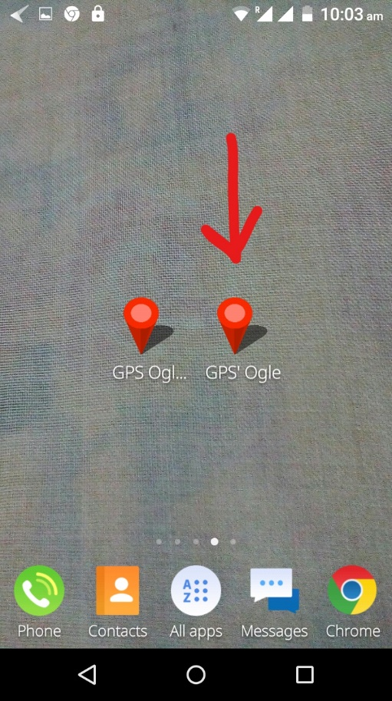S**tep 1:**

Fig 4.1:Launcher Icon

**Screen 2:**

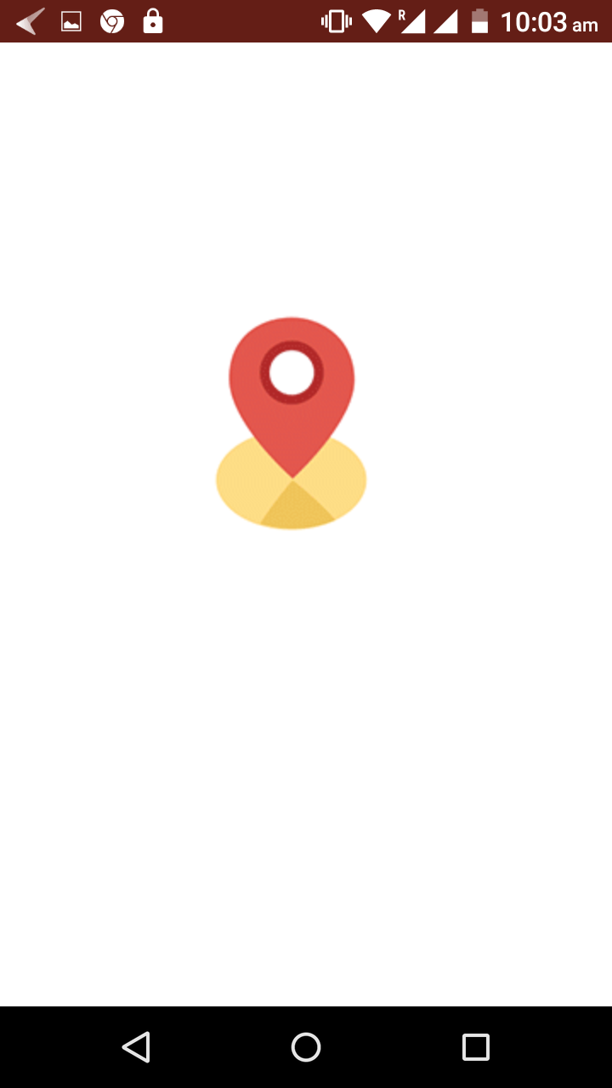

Fig 4.2:Splash Screen

**Screen 3:**

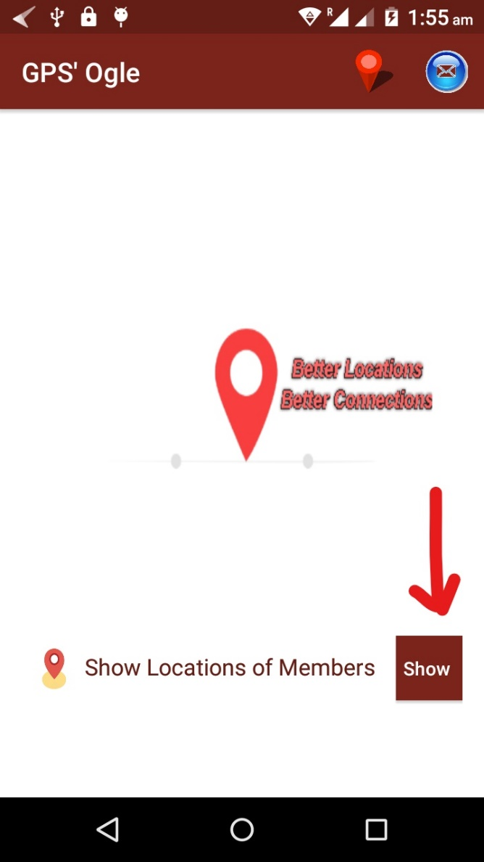

Fig 4.3:Main Activity of Client App

### Clicking on Show Button

Show button takes the users to next activity i.e Maps Activity. This is the most important activity of whole app as here the locations are displayed on a map. Upper part of screen contains a list of all users using our other app whome we have named as “GPS Olge Drivers App”. Users can scroll down these name as well as click on them to display there locations. The Red line on map shows a user. The red ballon indicates that user is on this place right now and exact time can be seen by clicking on this ballon. Other side of line indicates the postion where user were before thus user can understand direction of movement too.

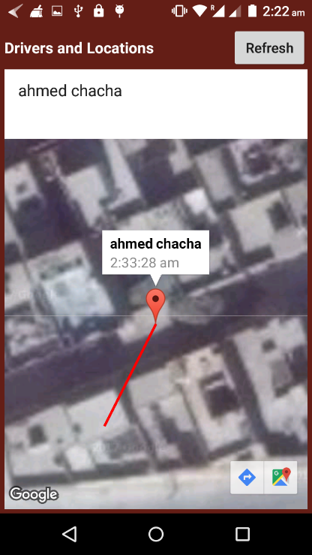

Fig 4.4:Maps Activity of Client App

### Clicking on Refresh Button

Button “Refresh” is there to get most recent locations of intended persons. On lower right corner, ther are two buttons that add up more functionality to app.

### Clicking on Arrow button

This button is part of Google Maps and it is there to show user’s distance from the person whose location user just found out. Here user can also find the time to reach that location either on cycle, on cycle or on foot as well as the route way of getting there.

**Screen 1:**

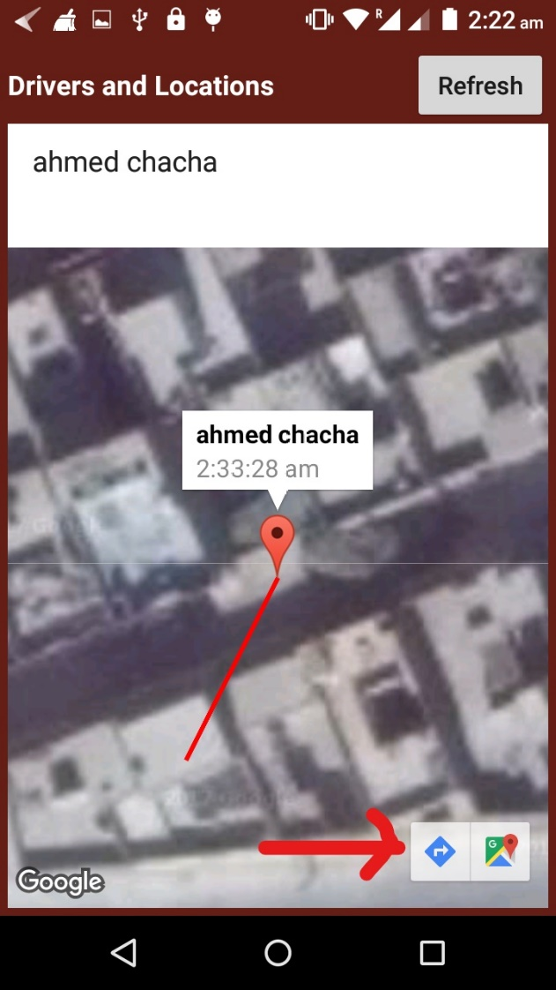

Fig 4.5:Arrow Button on Client App

**Screen 2:**

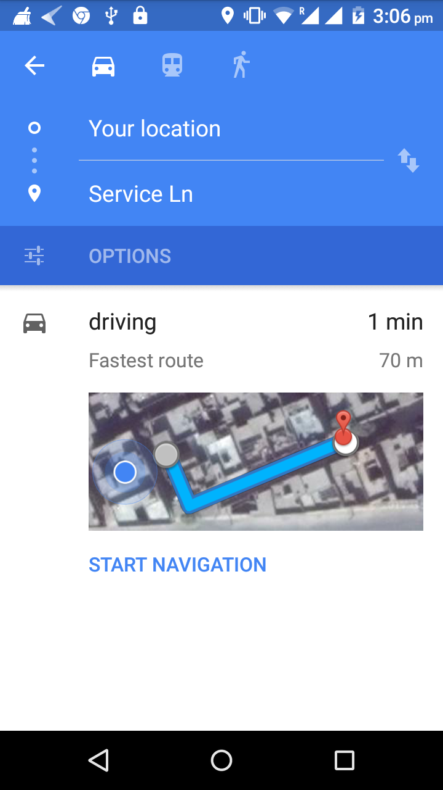

Fig 4.6:Clicked on Arrow Button

### Clicking on Maps Button

This very button takes user to google maps and here user can see exact latitude and longitude of the location where the persson being tracked is present.

**Screen 1:**

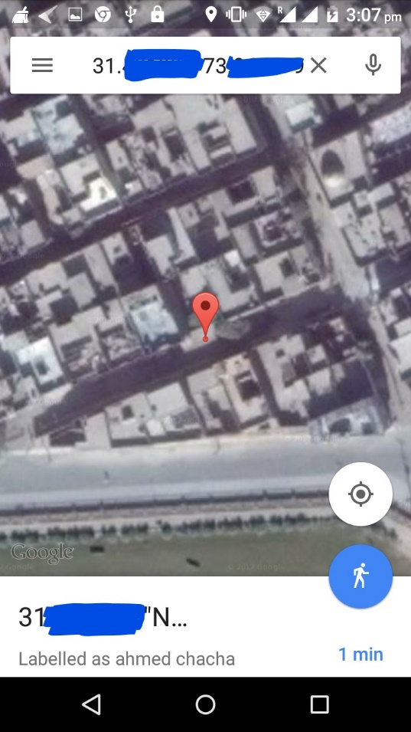

Fig 4.7:Clicking on Maps Button

**Screen 2:**

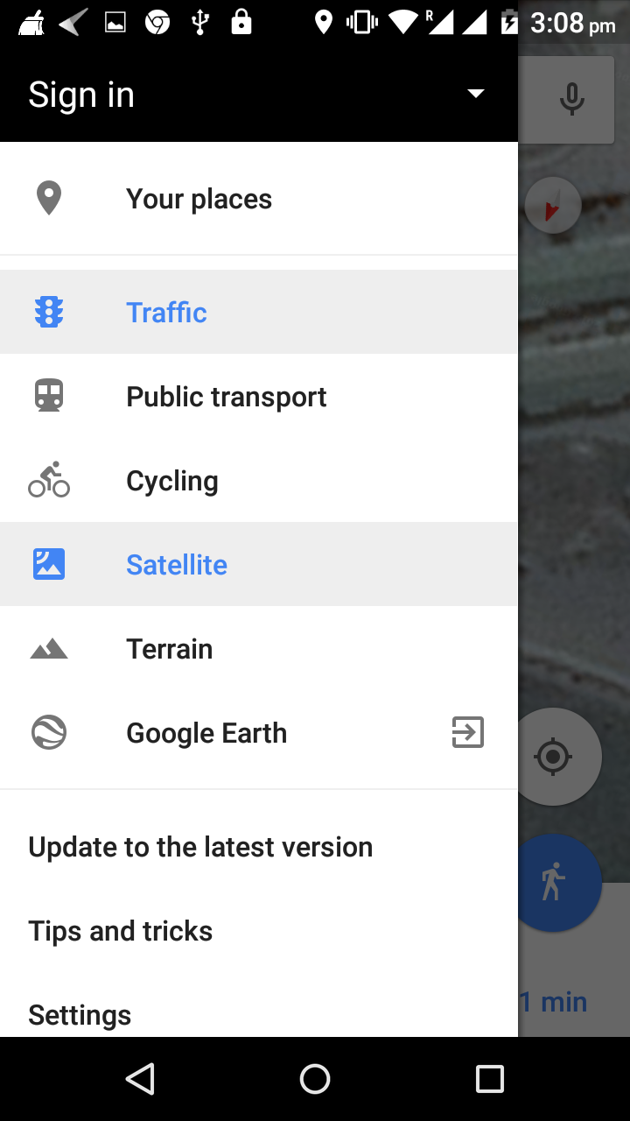

Fig 4.8:More Options in Maps

### Clicking on About

In Menu Bar, Button shown with a red ballon is to open the following activity which contains information about app and about us.

About App describes some information about (PROJECT NAME XYZ.....) .Motivation shows the reason behind developing this app. Functionality shows the main technique behind working of app.

**Screen 1:**

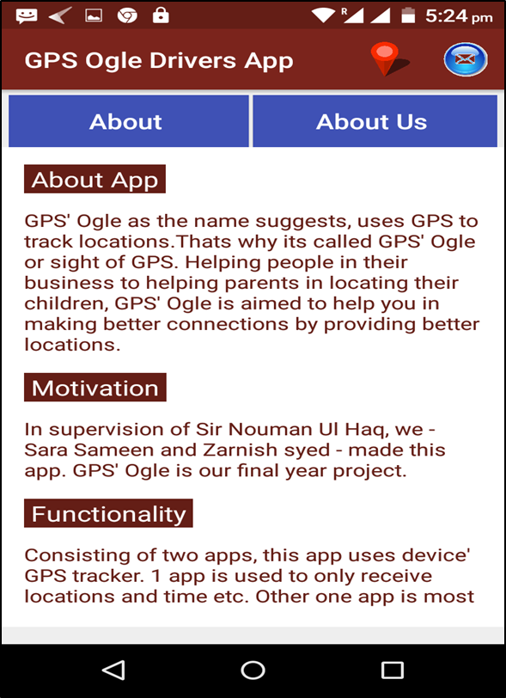

Fig 4.9:About Activity:

**Screen 2:**

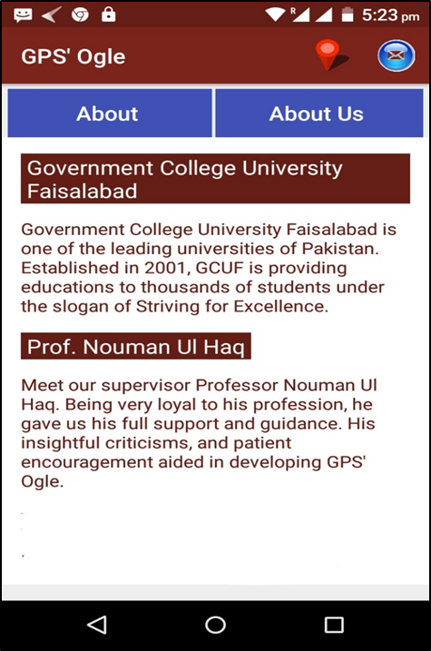

Fig 4.10:About Us Activity

### Clicking on Contact Us

The blue button on upper right corner of App’s interface, with a logo of email inside, is

there for contact. Following is the activity that user will find on clicking this blue button.

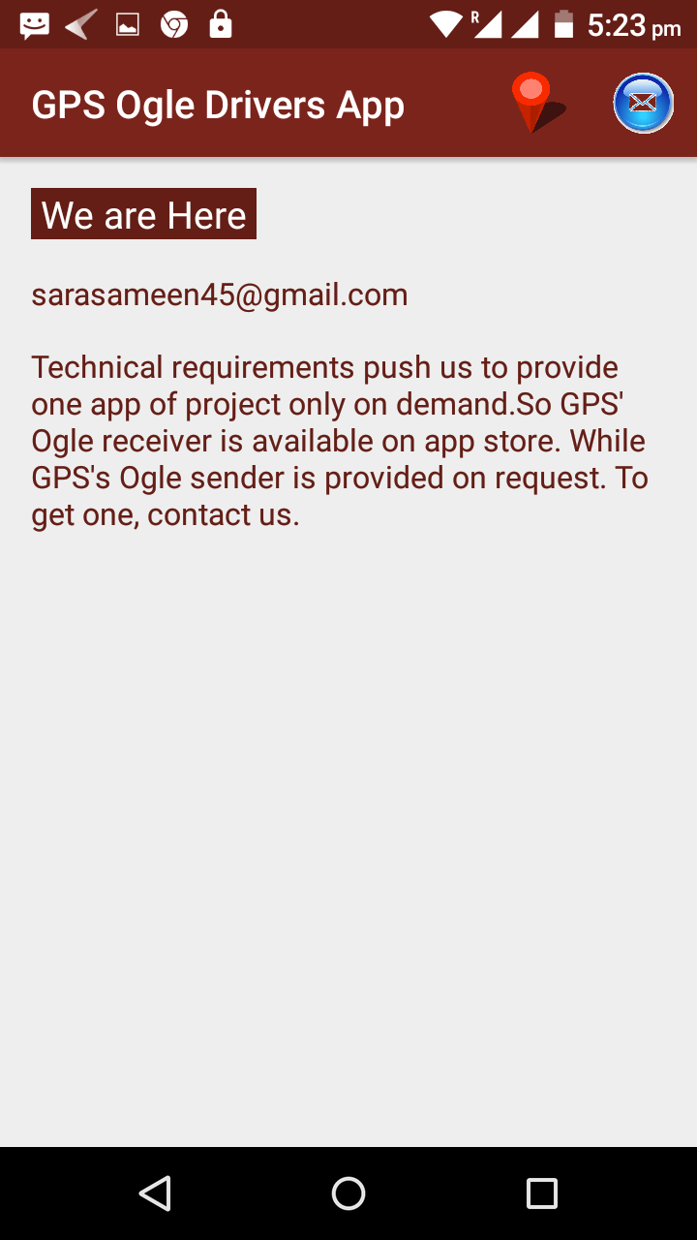

Fig 4.11:Contact Activity

### Getting Started with (Project Name XYZ.....) Driver’s App

As soon as the person being tracked i.e some driver or othe r moving person ,this screen appears after splash screen. This is for registration. Name is entered here and this name is as for tracking id.

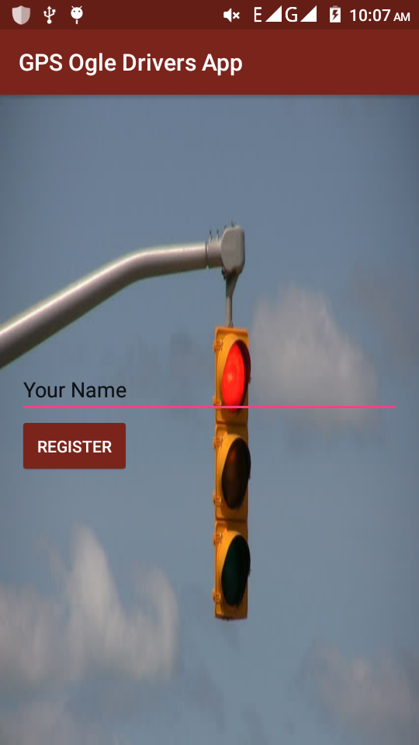

Fig 4.12:Registration Activity

### Starting tracking

After successfuly being registered, the person being registered is directed to following activity. By clicking on button “Start Tracking” user will be started being tracked and he/she will taken to anothe activity where he/she can see his/her position on a map.

**Screen 1:**

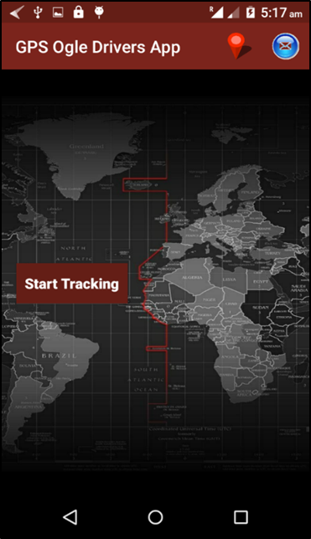

Fig 4.13:Main Screen of (Project Name XYZ.....) Driver's App

**Screen 2:**

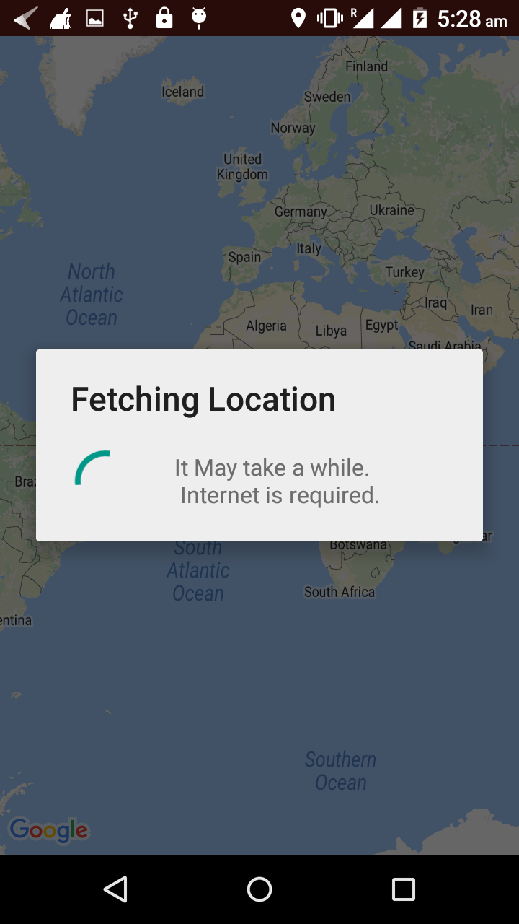

Fig 4.14:Getting Location in (Project Name XYZ.....) Driver's App

**Screen 3:**

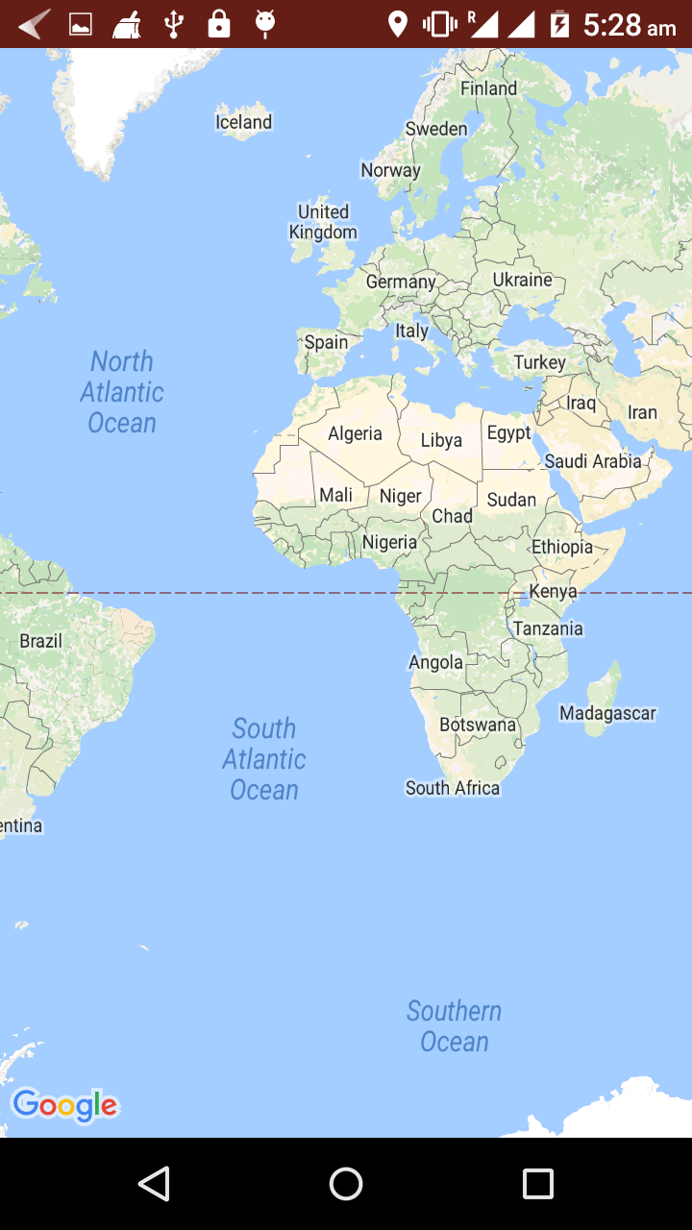

Fig 4.15:Maps Activity of (Project Name XYZ.....)

## Code of Main activity

The very first activity of app after splash screen is mainactivity. The front end is build in XML and backend is in JAVA.

### Explaination

In XML file, there is a gif image view, a text view and a button of “show”. Two more buttons are on top included from “menu” resourse. These are image buttons. In JAVA file, “oncreate()” is called when activity gets laucnched and in this function XML layout file is called. “on create options menu()” is for the above two image view buttons and it is used to iflate this above menu. “c1()” is called when SHOW button is clicked and it takes users to other activity i.e MapsActivity.Java.

### MainActivity.xml

<pl.droidsonroids.gif.GifImageView

android:layout_width="42dp"

android:layout_height="57dp"

android:background="@drawable/introgif"

android:id="@+id/gifImageView"

/>

<TextView

android:layout_width="wrap_content"

android:layout_height="wrap_content"

android:text="Show Locations of Members"

android:textColor="@color/me\hron"

android:textSize="17dp"

android:elevation="9dp"/>

<Button

android:text="Show "

android:onClick="cl"

android:layout_width="wrap_content"

android:layout_height="wrap_content"

android:id="@+id/button"

android:textColor="@color/white"

android:textSize="14dp"

android:padding="0dp"

android:backgroundc cvx="@color/lightmehron"

android:elevation="9dp"

android:layout_marginLeft="15dp"

android:layout_alignParentBottom="true"

android:layout_toRightOf="@+id/gifImageView"

android:layout_toEndOf="@+id/gifImageView"

android:layout_marginStart="15dp" />

### MainActivity.java

public void cl(View view) {

Intent intent = new Intent(MainActivity.this,MapsActivity.class);

startActivity(intent); }

@Override

public boolean onCreateOptionsMenu(Menu menu) {

MenuInflater menuInflater =getMenuInflater();

menuInflater.inflate(R.menu.menu,menu);

return super.onCreateOptionsMenu(menu);

}

@Override

public boolean onOptionsItemSelected(android.view.MenuItem item) {

switch (item.getItemId())

{ case R.id.About:

Intent intent = new Intent(MainActivity.this,About.class);

startActivity(intent);

break;

case R.id.Contact:

Intent intent3 = new Intent(MainActivity.this,Contact.class);

startActivity(intent3);

break;

default:

Toast.makeText(this,"choose something",Toast.LENGTH_LONG);

} return super.onOptionsItemSelected(item);

}}

## Maps Activity

Maps activity contains data that is sent by “drivers” through their app. It shows their names,current location,time and previous location. Further playing with app, one can check the distance between these locations and oneself as well as can find out time to reach some where on car or cycle or train etc. Further one can enjoy world’s map too.

### Explaination

XML file contains “list view ” that can be scroll down and can be clicked to see any driver’s position and time or fetching this position. It contains a Map fragment that is used to display the location on it.

Java file contains a “Vooley ” request to receive data from web based data base. All data is stored in an array “result”. This data is received in JSON formate and then converted form string to required data types. This is then further displayed when user clicks on some list item.

### Activiy_Maps.xml

<fragment

android:id="@+id/map"

android:name="com.google.android.gms.maps.SupportMapFragment"

android:layout_width="match_parent"

android:layout_height="match_parent"

tools:context="com.example.engineerswork.gpsogleclient.MapsActivity"

android:layout_alignParentBottom="true"

android:layout_below="@+id/scroll1" />

<ScrollView

android:layout_width="wrap_content"

android:layout_height="80dp"

android:id="@+id/scroll1"

android:paddingBottom="0dp"

android:layout_below="@+id/display"

android:background="@color/white">

<ListView

android:layout_width="match_parent"

android:layout_height="match_parent"

android:id="@+id/listView"

android:padding="0dp"

/>

</ScrollView>

<TextView

android:text="Drivers and Locations"

android:layout_width="wrap_content"

android:layout_height="50dp"

android:layout_alignParentTop="true"

android:layout_alignLeft="@+id/scroll1"

android:layout_alignStart="@+id/scroll1"

android:id="@+id/display"

android:gravity="center"

android:textColor="@color/white"

android:textStyle="normal|bold"

android:textSize="15sp" />

<Button

android:layout_width="wrap_content"

android:layout_height="50dp"

android:text="Refresh"

android:onClick="current"

android:id="@+id/imageButton"

android:layout_alignParentRight="true"

android:layout_alignParentEnd="true"

android:layout_alignParentTop="true"

android:adjustViewBounds="true"

android:cropToPadding="true"

android:scaleType="centerCrop"

android:elevation="0dp"

android:visibility="visible" />

### MapsActivity.java

public class MapsActivity extends FragmentActivity implements OnMapReadyCallback { ListView ls;

private GoogleMap mMap;

TextView display;

String url = "http://gcufbus.000webhostapp.com/get.php?";

String JSON_ARRAY = "result";

String addressText = "Loading Address";

JSONObject bus;

MarkerOptions markerOptions;

ProgressDialog progressDialog;

public class data

{

public Double lat, longitude, plat, plongitude;

public String name, time, pre_time, cur_address, pre_address = "";

public LatLng cur_position, pre_position;

}

@Override

protected void onCreate(Bundle savedInstanceState) {

super.onCreate(savedInstanceState);

setContentView(R.layout.activity_maps);

ls = (ListView) findViewById(R.id.listView);

display = (TextView) findViewById(R.id.display);

location();

SupportMapFragment mapFragment = (SupportMapFragment) getSupportFragmentManager()

.findFragmentById(R.id.map);

mapFragment.getMapAsync(this); }

public void location() {

progressDialog = ProgressDialog.show(this, "Fetching Locations", "Getting Locations of Busses ", false, false);

StringRequest stringRequest = new StringRequest(url,

new Response.Listener<String>() {

@Override

public void onResponse(String response) {

progressDialog.dismiss();

showJSON(response);}},

new Response.ErrorListener() {

@Override

public void onErrorResponse(VolleyError error) {

progressDialog.dismiss();

Toast.makeText(MapsActivity.this, "Internet Disconnected", Toast.LENGTH_LONG).show(); }});

RequestQueue requestQueue = Volley.newRequestQueue(this);

requestQueue.add(stringRequest);}

private void showJSON(String response) {

final data arraydata[] = new data[7];

final String[] namearray = {"sas","fdfgvg"};

try { JSONObject jsonObject = new JSONObject(response);

JSONArray result = null;

result = jsonObject.getJSONArray(JSON_ARRAY);

for (int j = 0; j < 2; j++) {

bus = result.getJSONObject(j);

arraydata[j] = new data();

arraydata[j].name = bus.getString("name");

arraydata[j].lat = Double.valueOf(bus.getString("lat"));

arraydata[j].longitude = Double.valueOf(bus.getString("longitude"));

arraydata[j].plat = Double.valueOf(bus.getString("area"));

arraydata[j].plongitude = Double.valueOf(bus.getString("area1"));

arraydata[j].pre_time = bus.getString("beforeTime");

arraydata[j].time = bus.getString("time");

arraydata[j].cur_position = new LatLng(arraydata[j].lat, arraydata[j].longitude);

arraydata[j].pre_position = new LatLng(arraydata[j].plat, arraydata[j].plongitude);

markerOptions = new MarkerOptions();

new ReverseGeocodingTask(getBaseContext()).execute(arraydata[j].cur_position);

arraydata[j].cur_address = addressText;

new ReverseGeocodingTask(getBaseContext()).execute(arraydata[j].pre_position);

arraydata[j].pre_address = addressText;

mMap.addMarker(new MarkerOptions().position(new LatLng(arraydata[j].lat, arraydata[j].longitude)).title(arraydata[j].name).snippet(arraydata[j].time));

mMap.addPolyline(new PolylineOptions()

.add(arraydata[j].cur_position, arraydata[j].pre_position)

.width(5) .color(Color.RED)); mMap.moveCamera(CameraUpdateFactory.newLatLng(arraydata[0].cur_position));

namearray[j] = new String(arraydata[j].name); }

} catch (JSONException e) {

e.printStackTrace(); }

mMap.setMapType(GoogleMap.MAP_TYPE_SATELLITE);

mMap.animateCamera(CameraUpdateFactory.zoomTo(20));

ArrayAdapter <String> arr= new ArrayAdapter<String>(MapsActivity.this, android.R.layout.simple_list_item_1,namearray);

ls.setAdapter(arr);

ls.setOnItemClickListener(new AdapterView.OnItemClickListener() {

@Override

public void onItemClick(AdapterView<?> adapterView, View view, int i, long l)

{mMap.moveCamera(CameraUpdateFactory.newLatLng(arraydata[i].cur_position));

}});} public void current(View view) {

location(); }

@Override

public void onMapReady(GoogleMap googleMap) {

mMap = googleMap; }

private class ReverseGeocodingTask extends AsyncTask<LatLng, Void, String> {

Context mContext;

public ReverseGeocodingTask(Context context) {

super();

mContext = context; }

@Override

protected String doInBackground(LatLng... params) {

Geocoder geocoder = new Geocoder(mContext);

double latitude = params[0].latitude;

double longitude = params[0].longitude;

List<android.location.Address> addresses = null;

try {

addresses = geocoder.getFromLocation(latitude, longitude, 1);

} catch (IOException e) {

e.printStackTrace(); }

if (addresses != null && addresses.size() > 0) {

android.location.Address address = addresses.get(0);

addressText = String.format("%s,%s",

address.getMaxAddressLineIndex() > 0 ? address.getAddressLine(0) : "",

address.getLocality(),

address.getSubLocality();}}}

## GET.PHP

<?php

if($_SERVER['REQUEST_METHOD']=='GET'){

require_once('config.php');

$sql = "SELECT * FROM newrec";

$r = mysqli_query($conn,$sql);

$result = array();

while ($res = mysqli_fetch_array($r)) {

array_push($result,array(

"name" => $res[0],

"lat"=> $res[1],

"longitude"=> $res[2],

"area" => $res[3],

"time" => $res[4],

"area1" => $res[5],

"beforeTime" => $res[6] ) ); }

echo json_encode(array("result"=>$result));

mysqli_close($conn); }?>

### Explaination

GET.php is used to fetch data from data base present on server side. Require() gets file for connecting with data base. "SELECT * FROM newrec" fetch all data from database and “while ($res = mysqli_fetch_array($r)){}” loop colleects this data. Then “echo json_encode(array("result"=>$result)); “ converts this data to JSON formate which is then sent to client on request.

**Chapter 5**

**Software Test Documentation**

# Software Test Documentation

## Project Testing

Testing is the process of executing the program with the intention of finding out errors. During testing, the program to be tested is executed with a set of test cases and the output of the programs for th5e test case is evaluated to determine if the program is performing as it is expected to be. The success of testing in revealing errors in program depends critically on the test cases. In software system the use of testing is not limited to the testing phase. The results of testing are used later on during maintenance also. During testing a test suite can be used to see that modification doesn’t have any undesirable effect.

## Purposes of testing

Software testing enables making objective assessments regarding the degree of conformance of the system to stated requirements and specifications. Testing verifies that the system meets the different requirements including, functional, performance, reliability, security, usability and so on. This verification is done to ensure that we are building the system right. In addition, testing validates that the system being developed is what the user needs. In essence, validation is performed to ensure that we are building the right system. Apart from helping make decisions, the information from software testing helps with risk management. Software testing contributes to improving the quality of the product. You would notice that we have not mentioned anything about defects/bugs up until now. While finding defects / bugs is one of the purposes of software testing, it is not the sole purpose. It is important for software testing to verify and validate that the product meets the stated requirements / specifications. Quality improvements help the organization to reduce post release costs of support and service, while generating customer good will that could translate into greater revenue opportunities. Also, in situations where products need to ensure compliance with regulatory requirements, software testing can safeguard the organization from legal liabilities by verifying compliance.

## Benefits of Automated Software Testing

Test Automation is essentially using code to create programs that perform automated tests for your software. The way this is different from manual testing is, instead of actually performing the test, one creates an automated testing scenario and supervises it. Test automation is extensively used for regression testing, which seeks out new bugs in a program and separates them. Regression tests are generally extremely tedious and time consuming. Here is where automated tests come in and make life easy for a software testing professional. Apart from this code-driven testing type, the other arena for automated testing is user environment simulation. Testing software can be created to replicate typical user environment using automated keystrokes and mouse clicks. The software GUI response is recorded and analysed as per the automated input.

### Efficient Testing

Test automation is a way to make the testing process extremely efficient. The testing team can be strategically deployed to tackle the tricky, case specific tests while the automation software can handle the repetitive, time consuming tests that every software has to go through. This is a great way to not only save up on time, money and resources, but also to generate a high ROI.

### Up gradation and Reusability

One of the best aspects of test automation is that the testing software is reusable. Not only that, but with every new test and every new bug discovery, the testing software directory can be upgraded and kept up-to-date. Thus, even though one of the main criticisms against test automation is the expense, one has to realize that automation software is a long lasting, reusable product which can justify its cost.

### Consistency

Test automation provides a consistent platform for your testing needs. The tests for which automation is usually deployed are extremely tedious. Automation drastically reduces the margin of error in the testing scenario by going through pre-recorded instructions. Regression tests verify whether the pre-existing functionalities are suited for new versions, which is critical when new development in the existing software takes place. This novel consistency provides a much needed reliability for your testing protocols.

### Unique Programmability and Shelf Life

Not only can test automation software be built to exact testing specifications, it serves as a prime component for future testing scenarios. In-house automated software developed by testing firms are modelled such that they have enough flexibility to handle a unique product, while complying with the latest security and testing protocols. This makes test automation a powerful tool for time-saving, resourceful and top notch results.

### User Environment Simulation

One unique way in which testing automation affects the testing procedure is through simulation of a typical user environment through categorically deployed mouse clicks and keystrokes. GUI testing is one of the most time consuming and redundant procedures because the tester has to deploy the same procedures in mock user driven environments and check for issues in the responsiveness of the GUI. With automated testing this process becomes incredibly easy.

Get in touch with Optimus QA for more information regarding automated testing. As we saw above, automated testing can make things in the testing lab very easy and tester friendly. At the same time, it gives the software creator a unique advantage of quick, hassle free testing and a great way to save precious resources and stay ahead of the timeline.

## The basic levels of testing are:

* User Needs Acceptance Testing
* Requirements System Testing
* Design Integration Testing
* Code Unit Testing
* Levels of Testing
* System verification testing
* Alpha Testing
* Beta Testing

## User need acceptance Testing

User acceptance is a type of testing performed by the Client to certify the system with respect to the requirements that was agreed upon. This testing happens in the final phase of testing before moving the software application to Market or Production environment. The main purpose of this testing is to validate the end to end business flow. It does NOT focus on the cosmetic errors, Spelling mistakes or System testing. This testing is carried out in separate testing environment with production like data setup. It is a kind of black box testing where two or more end users will be involved.

### Who perform user acceptance testing

* Client
* End users

## Prerequisites of User Acceptance Testing

Following are the entry criteria for User Acceptance Testing

* Business Requirements must be available.
* Application Code should be fully developed
* Unit Testing, Integration Testing & System Testing should be completed
* No Showstoppers, High, Medium defects in System Integration Test Phase -
* Only Cosmetic error are acceptable before UAT
* Regression Testing should be completed with no major defects
* All the reported defects should be fixed and tested before UAT
* Traceability matrix for all testing should be completed
* UAT Environment must be ready
* Sign off mail or communication from System Testing Team that the system is ready for UAT execution.

## System Testing

The process of testing an integrated system to verify that it meets specified  
requirements.

## ****Analogy****

During the process of manufacturing a ballpoint pen, the cap, the body, the tail, the ink cartridge and the ballpoint are produced separately and unit tested separately. When two or more units are ready, they are assembled and Integration Testing is performed. When the complete pen is integrated, System Testing is performed.

### ****Method****

Usually, [Black Box Testing](http://softwaretestingfundamentals.com/black-box-testing/) method is used.

### ****Tasks****

* **System Test Plan**
  + Prepare
  + Review
  + Rework
  + Baseline
* **System Test Cases**
  + Prepare
  + Review
  + Rework
  + Baseline
* **System Test**
  + Perform

### When is it performed****?****

System Testing is performed after [Integration Testing](http://softwaretestingfundamentals.com/integration-testing/) and before [Acceptance Testing](http://softwaretestingfundamentals.com/acceptance-testing/).

### Who performs it?

Normally, independent Testers perform System Testing. performs testing.

## Unit Testing:

The level of testing is called unit testing. In this, different modules are tested against the specifications produced during design for the modules. Unit testing is essential for verification of the code produced during the coding phase, and hence the goal is set to test the internal logic of the modules.

A unit is the smallest testable part of software. It usually has one or a few inputs and usually a single output. In procedural programming a unit may be an individual program, function, procedure, etc. In object-oriented programming, the smallest unit is a method, which may belong to a base/ super class, abstract class or derived/ child class. Some treat a module of an application as a unit. This is to be discouraged as there will probably be many individual units within that module. Unit testing frameworks, drivers, stubs, and mock/ fake objects are used to assist in unit testing

### Who performs it?

Unit Testing is normally performed by software developers themselves or their peers. In rare cases it may also be performed by independent software testers.

*Fig 5.1:Testing Diagram*

## Integration Testing

The next level of testing is often called the integration testing. In this, many tested modules are combined into subsystems, which are then tested. The goal here is to see if the modules can be integrated properly, the emphasis being on testing interface between modules. This testing activity can be considered as testing design, and hence the emphasis on testing modules interactions.

[**Integration testing**](http://softwaretestingfundamentals.com/integration-testing/)**:**Testing performed to expose defects in the interfaces and intheinteractions between integrated components or systems.

**Component**[**integration testing**](http://softwaretestingfundamentals.com/integration-testing/)**:**Testing performed to expose defects in the interfaces andinteraction between integrated components.

**System**[**integration testing**](http://softwaretestingfundamentals.com/integration-testing/)**:**Testing the integration of systems and packages; testing interfaces to external organizations (e.g. Electronic Data Interchange, Internet).

## System Testing

During system testing, the system is used experimentally to ensure that the software doesn’t fail, i.e. it will run according to its specifications and in the way users expect, special test data input for processing, and the results examined. A limited number of users may be allowed to use the system can see whether they try to use it in unforeseen ways.

## Acceptance Testing

It is sometimes performed with realistic data of the user to demonstrate that the software is working properly. Testing here focuses on the external behavior of the system. The internal logic of the program is not emphasized.

## Validation Check

During testing section validations checks are made. Appropriate actions are taken after testing.

## Implementation

Implementation is the stage of the project when the theoretical design turned into a working system. At this stage the main workload, the up heal and the major impact on the existing practices shift to user department. If the implementation stage is not carefully planned and controlled, it can cause chaos. Thus it can be considered to be the most crucial stage in achieving a new successful system and in giving the users confidence that the users confidence that the new system will work and be effective.

The implementation view of application requirements presents the real worlds manifestation of processing functions and information structures. In some cases a physical representation is developed as the first step in application design. However most computer based systems are specified in a manner that dictates accommodation of certain implementation details.

Implementation involves careful planning, investigation of current system and constraints on implementation, design of methods to achieve the changeover, training of staff in the changeover procedures and evaluation of changeover methods. The first task is the implementation planning i.e. deciding the methods and time scale to be adopted.

Once the planning has been completed, the major effort in the computer department is to ensure that the programs in the system are working properly. At the same time the user department must concentrate on training user staff. What the staffs have been trained, a full system test can be carried out, involving both the computer and clerical procedures.

The main step of implementation includes:

1. Installing user machine.

2. Installing the software in the user machine.

## System Verification

[System Verification](http://sebokwiki.org/wiki/Verification_(glossary)) is a set of actions used to check the correctness of any element, such as a [system element](http://sebokwiki.org/wiki/System_Element_(glossary)), a [system](http://sebokwiki.org/wiki/System_(glossary)), a document, a [service](http://sebokwiki.org/wiki/Service_(glossary)), a task, a [requirement](http://sebokwiki.org/wiki/Requirement_(glossary)), etc. These types of actions are planned and carried out throughout the [life cycle](http://sebokwiki.org/wiki/Life_Cycle_(glossary)) of the system. Verification is a generic term that needs to be instantiated within the context it occurs. As a process, verification is a transverse activity to every life cycle stage of the system. In particular, during the development cycle of the system, the verification process is performed in parallel with the [system definition](http://sebokwiki.org/wiki/System_Definition_(glossary)) and [system realization](http://sebokwiki.org/wiki/System_Realization_(glossary)) processes and applies to any activity and any product resulting from the activity. The activities of every life cycle process and those of the verification process can work together. For example, the [integration](http://sebokwiki.org/wiki/Integration_(glossary)) process frequently uses the verification process. It is important to remember that verification, while separate from [validation](http://sebokwiki.org/wiki/System_Validation), is intended to be performed in conjunction with validation.

The importance of a technology application very likely determines the degree of rigour applied to verifying, testing and maintaining the technology.

## Alpha Testing

Alpha testing is a type of acceptance testing; performed to identify all possible issues/bugs before releasing the product to everyday users or public.  The focus of this testing is to simulate real users by using blackbox and whitebox techniques. The aim is to carry out the tasks that a typical user might perform. Alpha testing is carried out in a lab environment and usually the testers are internal employees of the organization. To put it as simple as possible, this kind of testing is called alpha only because it is done early on, near the end of the development of the software, and before beta testing.

## Beta Testing

Beta [Testing](http://www.guru99.com/alpha-beta-testing-demystified.html) of a product is performed by "real users" of the software application in a "real environment" and can be considered as a form of external user acceptance [testing](http://www.guru99.com/alpha-beta-testing-demystified.html). Beta version of the software is released to a limited number of end-users of the product to obtain feedback on the product quality. Beta [testing](http://www.guru99.com/alpha-beta-testing-demystified.html) reduces product failure risks and provides increased quality of the product through customer validation. It is the final test before shipping a product to the customers. Direct feedback from customers is a major advantage of Beta [Testing](http://www.guru99.com/alpha-beta-testing-demystified.html). This [testing](http://www.guru99.com/alpha-beta-testing-demystified.html) helps to tests the product in real time environment.

## Types of Beta [Testing](http://www.guru99.com/alpha-beta-testing-demystified.html)

There are different types of Beta tests, and they are as follows:

Traditional Beta [testing](http://www.guru99.com/alpha-beta-testing-demystified.html):Product is distributed to the target market, and related data is gathered in all aspects. This data can be used for Product improvement.

Public Beta [Testing](http://www.guru99.com/alpha-beta-testing-demystified.html):Product is publicly released to the outside world via online channels and data can be gathered from anyone. Based on feedback, product improvements can be done.

Technical Beta [Testing](http://www.guru99.com/alpha-beta-testing-demystified.html):Product is released to the internal group of an organization and gather feedback/data from the employees of the organization.

Focused Beta**:**Product is released to the market for gathering feedback on specific features of the program. For example, important functionality of the software.

Post release Beta:Product is released to the market and data is gathered to make improvements for the future release of the product.

**Chapter 6**

**Post Mortem Report**

# Post Mortem Report

## Our roles & tasks

The product is completed by working together and combined. I Saara Sameen did main functionality of the project i.e coding / scripting and in deliverables I did SRS, SDD, working software and STD. while my other partner Farva build rest of the work in documentation and user manual.

## What worked well?

Mutual understanding between us was a plus point to complete this project. Most of the time we managed things by discussing together with the supervisor. Regarding working software everything is working properly. Moreover our idea to build this App was very rare. This App will help the users a lot.

## Team effectiveness

I would not be able to complete this project without assistance of my team mate Farva think we both are perfect team mates. Here are some characteristics that comprise high performance.

* The team has a common focus, including clear and understandable goal, plans of action, and ways to measure success.
* Roles and responsibilities are clearly defined for each team member.
* Each member has clearly defined expectations of other members.
* Each member is able to give, receive, and elicit necessary feedback.
* The team members manage their meetings in a productive way.
* The team is able to reach goals by achieving the necessary results.

## Lesson learned

At the end of the project, there we have learned many things and we are probably smarter than when the project started. We have experienced issues, probably several that were complete surprises, and we hopefully worked our way around them. We have learned some things simply by performing the project management practices throughout the project and watching the life-cycle processes play out. Now is the time to document those issues and workarounds and to enlist our very capable team members and stakeholders in that process as well. Our goal is to be able to operate more effectively and more efficiently on future projects and to also be able to share our experiences with our PM colleagues so that they may use this information wisely as well. After all, why would anyone want to repeat the same mistakes former seniors made?

The lessons learned document contains information about all the project life-cycle processes but most important the Executing and Controlling processes. These two processes are when the work of the project is performed and when you’ll likely find mistakes that were made in the Planning documents or processes. Anything you discover that could have been clearer or any additional information that would have helped to avoid confusion should be noted here. Process improvements, communication glitches, or any other information that will help you perform the next project better should be noted here.

## **Conclusion of the Project**:

I have completed my project under the title of ‘(Project Name XYZ.....)’. It fulfilled all the basic requirements of the user. It is designed to enhance interaction among people. The tools were selected for the project. After selecting the tools the actual coding of the project was started in coding java and android studio is used. Firstly the main functionality was implemented then the further modules of the project were designed out which include different services and main menu.. At that level I have to face a lot of difficulties. After a hard struggle and research the logic was designed out tracking a person and shareing location with others and that logic fulfills the App requirements.

Hence the project is successfully done and works accordingly.